**Color Board- Twin Girls’ Bedroom**

**Flooring and Walls**





**[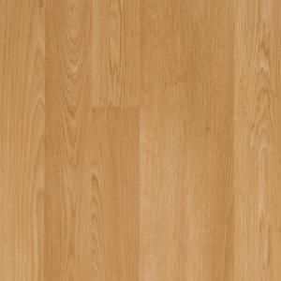](javascript:openFeatureFlex('http://fp.vendaria.com/vpop/VpopViewer.html?uid=100676763&iid=AddpfzvImumvmKvJJIIKfwKILumLKv&bg=FFFFFF&nm=BZOpener&err=0&title=&pf=t&fr=t','','587','632',true,false,false,false,false,false);)**

**Name:** Wall Paint-

**Color:** Ballet Slipper Pink

**Name:** Accent Wall

**Color:** Blooming Fuchsia

**Name:** Laminate Wood Planks

**Color:** Oak

[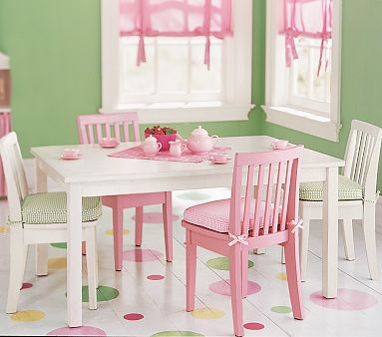](http://www.potterybarnkids.com/products/carolina-large-table/popup/more-views.html?active=2)

[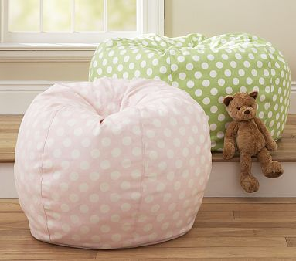](http://www.potterybarnkids.com/products/anywhere-recycled-beanbag/popup/more-views.html?active=2)

**Furniture**

**Name:** Storage System

**Color:** White and Black

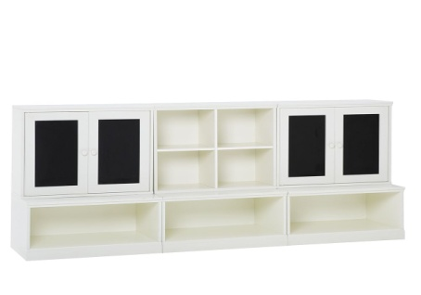

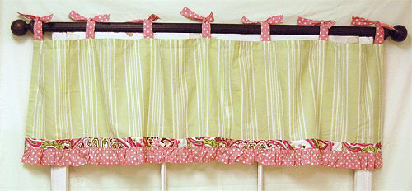

**Name:** Regular Recycled Anywhere Bean Bags

**Color:** Polka Dot Pink and Green

**Name:** Carolina Large Table and Chairs

**Color:** Table-White

Chairs- 2 White & 2 pink

**Window Treatments**

**[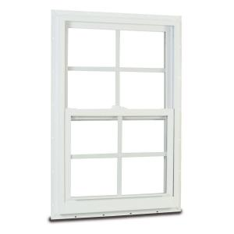](javascript:openLayer('popup-enlarge-image');)**

**Name:** Paisley Splash Valance

**Color:** Pink and Green

**Color:** White

(On Back of Display) Client Description

This playroom is for twin little girls. These sisters, age 4 are both very creative and love to draw and make different art projects. Their parents have their own travel agency out of their home so they are able to spend time with girls and supervise them in their awesome playroom. There are a total of four people in this home. The girls both love pink and green and helped picked out the colors. The large storage system is meant to keep the girls art supplies organized such as paper, colored pencils, paint, sparkles, and colored pens. The wall colors are meant to be bright, colorful, and inspirational. The furniture is meant for younger girls but can easily be replaced when they get older. The bean bags are for when the girls want to relax and later, read. The wood floors are actually laminate, which is easy to clean if a mess is made and are harder to dent than wood floors. This room is perfect for these little girls and accommodates their creative imaginations.