Kitchen 1 - Mixed Greens with Hard White Cheese and Pomegranate Dressing
Nutrition Info Calories: 149.2 Fat: 9.5g Carbohydrates: 12.5g Protein: 5.8g

Ingredients
1/3 cup Simply Dressed® Pomegranate Salad Dressing or similar dressing
1 large Jicama, pealed and diced
3 oz hard white cheese
1/2 cup almonds, coarsely chopped
2 pears, cored and cut into slices
5 oz favorite mixed greens

Directions
- Cut Jicama into diced pieces and place in a large mixing bowl.
2. Using a vegetable peeler, peel cheese into thin strips over bowl – Do this on serving day.
3. Add remaining ingredients
- On serving day add dressing- Pomegranate Salad Dressing to mixing bowl and gently toss together. Serve
Serving Size: Makes 6 servings

Baked Zucchini Sticks- - Kitchen- 2
Canola or olive oil cooking spray
1/2 cup whole-wheat flour
1/2 cup all-purpose flour
2 tablespoons cornmeal
1 teaspoon salt
1/2 teaspoon freshly ground pepper
1 1/2 pounds zucchini, (about 3 medium), cut into 1/2-by-3-inch sticks
2 large egg whites, lightly beaten

Preparation
- Preheat oven to 475°F. Coat a large baking sheet with cooking spray.
- Combine flours, cornmeal, salt and pepper in a large sealable plastic bag. Dip zucchini in egg white, shake in the bag to coat, and arrange, not touching, on the baking sheet. Coat all exposed sides with cooking spray.
- Bake on the center rack for 10 minutes. Turn the zucchini and coat any floury spots with cooking spray. Continue to bake until golden and just tender, about 8 to 10 minutes more. Serve hot.

Nutrition
Per serving : 127 Calories; 2 g Fat; 0 g Sat; 0 g Mono; 0 mg Cholesterol; 23 g Carbohydrates; 7 g Protein; 4 g Fiber; 427 mg Sodium; 524 mg Potassium
1 1/2 Carbohydrate Serving
Exchanges: 1 starch, 1 1/2 vegetable

Kitchen 3-

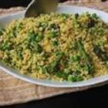
Couscous Primavera
"Combine couscous with fresh asparagus, green peas, and mint to create a light, delicious springtime side dish."
Ingredients:
2 cups couscous  1/2 cup chopped green onions (frozen)  1 fresh green pepper, finely diced(frozen)  2 tablespoons olive oil  1/2 teaspoon ground cumin  1 pinch cayenne pepper  1 pinch ground black pepper | 2 cups vegetable stock- use bullion  1 bunch asparagus, trimmed and cut into  1/4-inch pieces  1 cup fresh snow peas, chopped Julienne  2 tablespoons chopped fresh mint  salt and freshly ground black pepper to  taste
Directions:
1. | Combine couscous, green onion, jalepeno, olive oil, cumin, cayenne pepper, and black pepper in a large bowl; stir until olive oil is completely incorporated.
2. | Bring vegetable stock, asparagus, and peas to a boil in a saucepan over high heat.
3. | Pour stock, asparagus, and peas over couscous mixture; shake bowl to settle couscous into liquid. Cover and let stand for 10 minutes. Fluff with a fork, then stir in mint and season with salt and pepper to taste.

ALL RIGHTS RESERVED © 2013 Allrecipes.com | Printed from Allrecipes

EASY BAKED BEANS- Kitchen 4
Printed from COOKS.COM

3 cans baked beans
1 can kidney beans, drained
1 can butter beans, drained
1 tsp. mustard
1/4 c. ketchup
1/4 c. brown sugar
6 slices bacon precooked
1 sm. onion, chopped (frozen)
Crumble bacon. In largest pan, add all of the above, stir well. Cook on med high for about 20 minutes, stirring constantly and then simmer on low for 1 1/2 hours or can be baked in 350 degree oven for 1.5 hours.

Honey Cornbread Kitchen 5- Double the Recipe

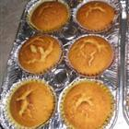
  Prep Time: 8 Minutes  Cook Time: 25 Minutes | Ready In: 34 Minutes  Servings: 8
"A sweet cornbread that will crumble in your hand and melt in your mouth."

Ingredients:
1 cup all-purpose flour  1 cup yellow cornmeal  1/4 cup white sugar or sugar substitute  1 tablespoon baking powder | 1 cup heavy cream or lite sour cream Use FAGE yogurt  1/4 cup vegetable oil  1/4 cup honey or Karo  2 eggs, lightly beaten

Directions: Double Recipe- Spray 8 x8 inch pans with vegetable spray.

1. | Preheat oven to 400 degrees F (200 degrees C). Lightly grease a 9x9 inch baking pan.
2. | In a large bowl, stir together flour, cornmeal, sugar and baking powder. Make a well in the center of the dry ingredients. Add the cream, oil, honey and eggs; stir to combine. Pour batter into prepared baking pan.
3. | Bake in preheated oven for 20 to 25 minutes, until a toothpick inserted into center of pan comes out clean.

New Red Potato Salad- Kitchen 6
This simple chilled potato salad makes great use of unpeeled red potatoes, hard cooked eggs, celery and a mayonnaise mixture. It's perfect for the big cookout!"
INGREDIENTS: Prep Time: 20 Minutes
Cook Time: 15 Minutes
3 pounds unpeeled red potatoes, cut into small bite size pieces  4 eggs- hard boiled  1 1/2 cups mayonnaise- “lite” version  ½ cup chopped dill pickles or ½ tsp dill weed- Dr.Baglien bring from home.  ½ cup milk or dill pickle juice could be substituted. | 1/2 cup sliced green onions(frozen)  1/2 teaspoon salt  1/4 teaspoon ground black  pepper  1 cup finely chopped celery (frozen)
DIRECTIONS:
1. | Wash. red potatoes. Place in covered microwaveable dish, and cook until tender but still firm, about 10 minutes. Pierce each potato with a fork to be sure it is done. Cool by running under cold water, drain, and chop into 1 inch cubes. Place in a medium bowl.
2. | Place eggs in a medium saucepan, and cover with cold water. Bring water to a boil, and immediately remove from heat. Cover, and let eggs stand in hot water for 10 to 12 minutes. Remove from hot water, cool, peel and dice.
3. | In a small bowl, whisk together mayonnaise, milk, distilled white vinegar, green onions, salt and pepper. Pour the mixture over the potatoes, and mix together with the eggs and celery. Cover, and chill in the refrigerator approximately 2 hours before serving.

Kitchen 7

Easy Minestrone Soup
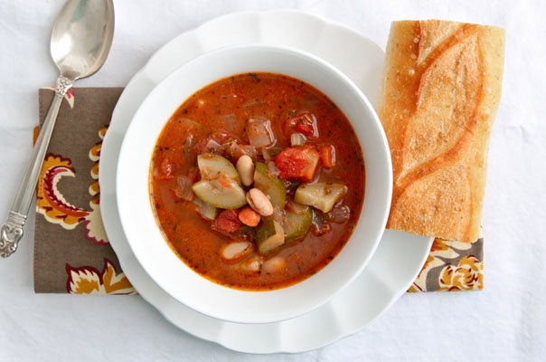
What You'll Need:
2 tablespoons olive oil
1 medium onion, diced
1 medium carrot, peeled and cut into 1/4-inch rounds(frozen)
2 celery stalks, chopped (frozen)
2 small zucchini, quartered and cut into 1/2-inch pieces
2 cloves garlic
2 tablespoons any combination of dried oregano, basil and/or thyme
1 28-ounce can diced tomatoes
6 cups vegetable or chicken stock
1 15-ounce can cannellini beans, drained and rinsed
Salt and fresh ground pepper
Add to the above
1/2 cup dry pasta (add this in the last 10 minutes of cooking)
2 cups shredded baby spinach or kale (frozen)
1 cup green beans, cut into 1-inch pieces
1 cup fresh or frozen corn or peas (frozen)
1 15-ounce can kidney beans
What to Do:
- Heat oil in a heavy bottomed pot over medium heat.
- Add the onion, carrot, celery, zucchini, and garlic, season with a pinch of salt and fresh ground pepper. Stir to coat with the oil and cook until tender, about 8 minutes.
- If using wine, add the wine to the pot and cook until it's almost entirely reduced.
- Stir in the dried herbs, diced tomatoes, and stock.
- Bring the soup to a boil, then reduce the heat and simmer uncovered for 30 minutes, adding the cannellini beans and pasta in the last 10 minutes of cooking. Taste and season with salt and pepper, as needed.
- Serve immediately.
- Store in a covered container in the refrigerator for up to one week, or freeze for up to three months.

