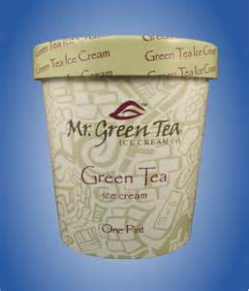The Profit

“Mr. Green Tea”

|  |  |
| --- | --- |
| Question | Answer |
| What is the product that Mr. Green Tea sells? |  |
| Mr. Green Tea is a profitable company so what would be the reason to expand this business? |  |
| In your opinion, what could be the strengths and challenges of having a family owned business? | List 2 Strengths:  1.  2.  List 3 Challenges:  3.  4.  5. |
| In the beginning, the partner of Mr. Green Tea left and created a famous ice cream company that we know today called ___________. | ________________ |
| The investor offered $ ______________ for ____% of the company. | $_____________  ___% |
| The son of Mr. Green Tea Company spent $18,000 on a promotion idea and bought what? | _______________ |
| The investor was upset with the son regarding the numbers of the building costs what was the issue? Why was he upset? |  |
| What is co-packing? |  |
| What are the benefits to co-packing? |  |
| What are the challenges to co-packing? |  |