**STUDENT PREP PACKET**

**GREATER AUBURN COMMUNITY CAREER CONFERENCE**

Emerald Downs

March 24, 2015

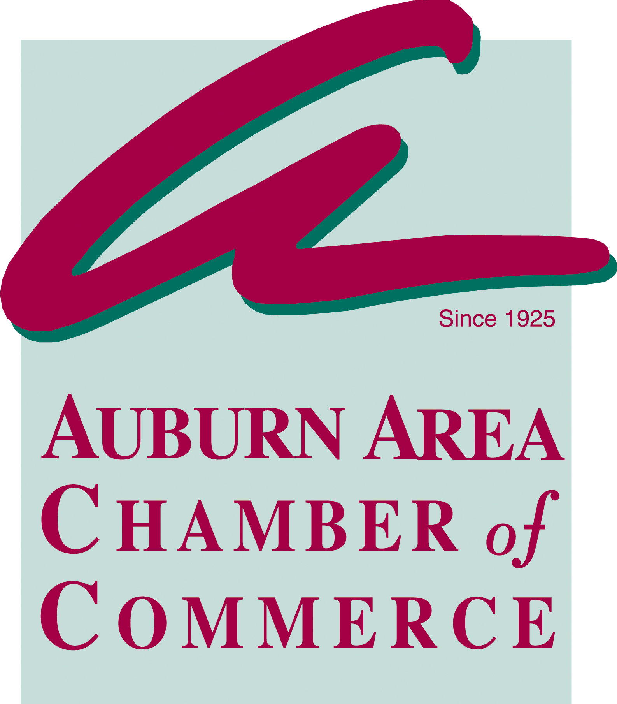





**HOW TO WRITE A RESUME**

A resume is a concise (usually one-page) description of your background, specifically as it relates to your current career objective. It is probably the first representation an employer sees of you, therefore; it must make a favorable impression. Styles and formats may vary depending on the purpose of your resume, so it is important to determine what is appropriate for you. A resume should be accompanied by a cover letter if you are sending it (need to have cover letter for Career Conference portfolio).

**Steps to Developing a Resume**

1. **Complete an analysis of your career or occupational goal**. What knowledge, skills/abilities, and personal characteristics are necessary for success? Speak to people in the field and faculty members. Review wants ads and job descriptions. Determine what employers are seeking.

2. **Review other resumes**. Look at many, many other resumes. This will give you a better idea of the range of possibilities, and what you like or do not like about the resume samples. After looking at a resume, can you determine what knowledge, skills, abilities, and personal characteristics the writer possesses? How did you reach these conclusions?

3. **Begin a draft** **resume** (preferably on a word processor). Write with an eye to establishing your qualifications, as established in your analysis of the knowledge, skills, abilities, and personal characteristics necessary in your career field.

4. **Have others critique your draft resume**. Share it with parents, friends, advisors and faculty. Incorporate the suggestions you find most helpful. **Don't worry if you receive** **inconsistent advice**; **remember there is not one right way to compose a resume**. When you are satisfied, print it.

While there are some standardized formats for the type of information you should include, the style of the resume should reflect your own preference. Since there are no absolutes for the proper way to categorize your experience, develop organizational headings which are useful to you and clear to others.

In drafting the resume, try to provide as much specific information about your activities as possible. Information on your educational background should reflect any independent study or internship experiences, international study, volunteer work, or any honors you have received. In describing previous work experience, you should include relevant information about your level of responsibility, particular accomplishments you achieved, recognition you received or initiative you took.

Since there are several common resume styles, it is important to select which is best for you based on your own background and objectives. In a **chronological resume** categories are arranged "most recent first." For example, work experience from 2003 would appear first and additional experience listed in reverse chronological order.

Many people find it helpful to adopt a **functional resume** style which enables them to focus directly on the skills that are relevant to the position for which they are applying. The functional resume lists specific accomplishments in categories related to your objective. For example, if your objective is a position involving research and writing, you would list experiences that specifically indicate your ability in these areas. This format is a good way to highlight accomplishments and competencies as opposed to titles, dates and addresses.

Keep the resume brief and to the point; each word should be descriptive and relevant. Whenever possible, avoid the use of the personal pronoun or any extraneous words. Try to use words that are most descriptive of the activity you are discussing; active verbs present a more positive impression than passive verbs. Avoid jargon and obscure acronyms.

**Your resume should appear attractive, error-free, easy to read, well organized and business-like.** Pay attention to underlining, capitalization, boldface type, and spacing. Provide adequate margins and use "white space" appropriately. Remember at times being simple can improve your effect, so try not to clutter up your resume, it might confuse the reader. Your resume should be designed in such a way that the reader can readily find any particular information that she/he may seek.

**Explanation of the Components of the Resume**

(These components are the most commonly used; remember that other headings are acceptable and encouraged if they better feature your background.)

**Identification** At the very top of the resume, give your full name (no nicknames), current and permanent addresses with zip codes and telephone numbers with area codes. Include the date or approximate date you will be at a temporary address. Your name should be highlighted either in capital letters or boldface type.

**Job Objective** The objective is optional but must be addressed in the cover letter if you omit it from the resume. State briefly what you want to do and in what field or kind of organization you want to perform this function. Be as specific as possible: no objective is better than a vague objective.

**Education** List your secondary school and graduation date for this conference, but omit it after attending college. Other academic interests should be included in addition to field of concentration, especially when related to your job objective. Extracurricular activities (if they were a substantial part of your life during school), important offices held and any honors you have received should also be mentioned or may be a separate category. Internships or practicum experience may be included here or listed in a separate category. Course projects related to your objective can be described either here or in an experience section.

**Experience or Achievements** Experience should be listed in reverse chronological sequence. Job descriptions should be brief but clear as to responsibility, department of activity and breadth of experience. Specific accomplishments may be included. Salary earned, name of supervisor, or employer address (except for city and state) should not be mentioned. Any summer or part-time work experience that required specific skills related to your field of interest, carried with it substantial responsibilities, or helped you develop particular skills should be described as well. Those which seem less related should be grouped together in a general summary statement. Don't assume that you should not explain a position just because it sounds mundane.

**Personal** This section is optional. Should you choose to include it, provide informal information about your background that an employer may like to know, such as; hobbies, activities, or traveling experiences that may stand out as unusual. Specific information such as birth date, health, height, weight or marital status is not required.

**References** Indicating references is optional; employers will assume you can provide them. You should identify three or four professionals (faculty, work, internship supervisors, club sponsors, etc.) who know you well enough to evaluate your abilities. Be sure to consult them prior to using their names and keep them informed of your job search progress.

**HOW TO WRITE A COVER LETTER**

Each time you send your resume to a company or organization for an internship or job, you must send it with a **"cover letter."** **The cover letter introduces you, tells why** **you are writing and encourages the employer to read your resume**. A well-written cover letter is just as important as a well-developed resume.

**There Are Two Types Of Cover Letters:**

**l. Letters of application written when you know the actual job for which you are applying.**

**2. Letters of inquiry are used when you are unaware of a specific job and are inquiring as to possible openings.** You need to be specific about what kind of position you are seeking. The employer will not decide for you.

**The cover letter needs to address three questions**. **Paragraph one** needs to answer the question, **"Why are you writing?"** Be concise and clear about what position or what kind of position you are interested in and how you learned about it. **Paragraph two** and sometimes paragraph three need to answer the question **"Why** **should I hire you?"** This is probably the hardest section to write. You should either provide more in-depth information about items you have mentioned on your resume or some additional information which is not listed on your resume. Demonstrate how your experience/education relates to the position for which you are applying.

**The final paragraph** needs to answer the question, **"What is the next step?"** We encourage you to let the employer know you will be contacting him/her regarding the possibility of an interview whenever this is possible.

**Letter Guidelines**

**l. Must be an original!** Do not send out copies from a printer or duplicating machine. Although your resume usually remains standard, your cover letter should be tailored to a specific organization and/or available position. The word processor is tremendous help here.

**2. Must be written in the standard business letter format, and include a heading, inside address, greeting, body, closing and signature.**

**3. Should be sent to a specific person.** This ensures that the letter and resume will end up on the right person's desk. This will also enable an easy follow-up on your part because you know who received the correspondence. A specific name will also help you to personalize it as appropriate.

If you do not have the individual's name, call the company/organization and ask the receptionist. "I am sending some correspondence to your director of sales. Would you please give me the correct spelling of his/her name and also the official job title? Thank you."

If for some reason you cannot obtain this person's name, address the letter to the person's job title (eg. Director of Personnel) and use the greeting, "Dear Sir or Madam." Also, when in doubt, use Ms. when greeting a woman.

**4. Must be typed!** Be sure that no typographical, spelling or grammatical errors are present. Many employers will not consider applicants if such errors exist. A haphazard attempt might indicate a potentially careless worker!

**5. Should be brief** (no more than one page), yet factual and professional. Avoid cliches, wordiness and pushiness.

**6. May be typed on the same paper stock as your resume.** Purchase extra blank sheets of matching paper and envelopes. The cost is usually minimal and the effect is highly professional. We recommend that you review other cover letters before composing your own. Two examples of cover letters are available for your review. **Be sure to follow up any application or inquiry**. If you have not heard from the company or organization one to two weeks later or shortly after the closing date, then follow up with a phone call. This allows you to know the status of your application, shows the employer your initiative and interest, and puts you in control of your job search. Don't call your contact person more than once during the same week. Find out the decision timetable during the first call and follow through accordingly.

**MAKING A GOOD FIRST IMPRESSION**

1. Your hair, mustache or beard are neatly trimmed and combed
2. You are freshly bathed, used a deodorant, and have clean manicured fingernails
3. Use mouthwash or breath-mints to eliminate odors resulting from strong food, drink, or tobacco
4. If you use cologne or perfume, the interviewer should not be able to tell that you have it on
5. Be on time
6. Greet the interviewer with a smile and shake their hand if they extend their hand, if they do not then skip the handshake
7. Sit up straight without slouching or leaning on your elbows
8. Maintain good eye contact throughout the interview
9. Listen closely and use non-verbal communication to show openness, friendliness, and enthusiasm
10. Do not chew gum
11. Use good grammar and speak clearly, without “ums”, “ahs”, and “ya knows”
12. Talk only 50% of the time
13. You treat the interviewer with courtesy and respect, regardless of your doing well in the interview or offered the job, if you make a good impression you may be referred to another person with an opening
14. Avoid clothing and accessories that will stereotype you such as jeans, hats, excessive jewelry, inappropriate T-shirts, sneakers, and anything that projects a poor impression

**HOW TO DRESS AT THE INTERVIEW- IMAGE IS IMPORTANT**

**Gentlemen**

1. Suit and a tie, conservative sport jacket, slacks, and tie, or shirt and tie (minimum) Remember to think “business” and not “prom.”Preferred colors for suits are blue and gray, blue for sport jackets
2. Business ties (red, blue, gold power ties) no inappropriate or Disney type ties.
3. Solid white or light blue shirts, striped shirts only if they are conservative
4. Polish your shoes the night before
5. Only one ring per hand, no necklace or ear jewelry, no tongue piercing
6. Dress watches are preferred
7. Pressed pants( It is worth the couple of bucks to have your shirt and pants pressed at a professional laundry)
8. Cologne that cannot be detected by the interviewer
9. If you have tattoos, try to see that they are covered up or made less distracting

**Ladies**

1. Conservative dresses or pants suits. Remember think “business” and not “prom”
2. Heels no higher than 1” and conservative shoes that match your look
3. Nylons or panty hose
4. Length of skirt or dress should be business like. Good rule of thumb is no shorter than 1” above the knee and no slits. Every office is different so be conservative now and be creative later.
5. Perfume that cannot be detected by the interviewer
6. Post earrings are preferred and only one per ear, no distracting jewelry of any kind, only one ring per hand, conservative watches, no tongue piercing
7. If you have tattoos, try to see that they are covered up or made less distracting
8. Hairstyle should be conservative with style and color
9. Hair is tied back or on top of head.

**MANNERS AND BUSINESS ETIQUETTE**

1. Good manners are important. They show that you are civilized and sociable.
2. The first manner an employer will look for is punctuality, showing up for the interview on time. It indicates whether you’re reliable and whether you’ll show up to work on time. Showing up late for the interview could hurt your chances of being hired in 70 percent of the interviews.
3. When you meet the interviewer-smile-offer a friendly greeting. Extend a firm handshake if they offer. This shows that you are sincere.
4. Remember their name. Address the interviewer as Mr. or Ms. unless they ask you to call them by their first name. This shows that you have respect for the position.
5. Once you are at the interview, do not sit until you are invited to sit. This shows that you have respect for the interviewer’s territory.
6. Never chew gum.
7. Do not touch your face. It says that you are trying to hide something.
8. Do not tap a pen, drum your fingers, swing your foot, or rock in the chair. It implies that you are being threatened.
9. Do not drop names of important people you know. It implies that you are important too and that you should be given special treatment.
10. Do not argue about anything, not even baseball.
11. Do not carry your coat up to the interview. It implies that you cannot wait to get out of here.

**Attitude**

Managers agree ***attitude***separates the winners from the losers. It can be more important than experience.

“Give me someone who’s enthusiastic and motivated”, explained one manager. “Someone who’s really excited about coming to work for me….someone who looks bright, alert, alive….someone who’ll look me straight in the eye….someone who is honest, wide-open smile….someone who sits on the edge of their chair….someone who uses their hands to show what they mean….someone who’s not afraid to say that they really want this job.”

**SAMPLE QUESTIONS ASKED BY EMPLOYERS**

1. Why should I hire you?
2. What are your long term career goals?
3. How do you work under pressure?
4. How long do you expect to work for us if we offer you the job?
5. What are your strengths and weaknesses?
6. How do you think a friend or teacher would describe you?
7. Why are you applying to this company?
8. What have you learned from your mistakes?
9. What are the most important rewards you expect from your business career?
10. How would you describe yourself?
11. What are some things, on any job, you have found difficult to do?
12. What are some of the things your boss did that you particularly liked or disliked?
13. What are some of the reasons you had for leaving other jobs?
14. What are some of the things in a job that are important to you?
15. What are some of the things you would like to avoid in a job and why?
16. What is your overall career objective?
17. What are your criteria for success?
18. What are current salary expectations?
19. What is your GPA?
20. What do you like best and least in school?
21. What extracurricular activities were you involved in, and to what extent?
22. What is something you have accomplished that you feel good about and why?
23. Why do you want to work for our company?
24. Have you ever had to deal with someone difficult, what was the situation and how did you handle it?
25. Is there anything that you would like to add to this interview that we have not covered?

**8 WORST THINGS TO SAY IN AN INTERVIEW**

*\*By Anthony Balderrama, CareerBuilder.com writer*

1. **“I hated my last boss”**

Your last boss may have been a miserable person, but make sure to differentiate from honesty, which is admirable and trash-talking, which is despicable.

1. **“I don’t know anything about the company.”**

Chances are you’ll be asked about the company, be prepared to provide a well put together answer. Not having any knowledge may imply that you’re after the money instead of the best interest of the company.

1. **“No, I don’t have any questions for you.”**

Not having any questions may imply lack of interest in the company, be prepared with a couple questions to show interest.

1. **“I’m going to need to take these days off.”**

We all have commitments in life; just don’t bring up time off prior to the salary negotiation/offer stage.

1. **“How long until I get a promotion?”**

Make sure to portray yourself as goal-oriented, instead of entitled.

1. **“Are you an active member in your church?”**

It’s good to attempt small talk, but make sure the topics you choose aren’t controversial or too personal.

1. **“As Lady Macbeth so eloquently put it…”**

Scripted answers don’t impress interviewers; they also prevent you from engaging in dialogue.

1. **“And another thing I hate…”**

Make sure to save your rants for another time and place. When you’re angry, you don’t sway anybody’s opinion on a topic, but you do make them like you less.

**CLOSING THE INTERVIEW**

You are almost done with the interview. Everything has gone well, you've answered the interviewer's questions well, and you actually felt pretty comfortable throughout the whole thing. Or maybe you feel that things didn't go that well, and you've got this sinking feeling that you won't get the job. Whichever is the case, make sure you leave the interview on a positive note. Many people have left an interview feeling they blew it, only to be surprised by a phone call from the employer a few days later offering them the job or another interview. You can never be sure what the other person thought of the interview, so it's a good idea to take every opportunity to leave a positive impression.

Here are a few suggestions of things to do as you leave the interview:

* If the employer asks you to call or return for another interview, make a written note as to date, time and place.
* If the employer does not let you know when a further contact will be made, ask when you may call to learn of his/her decision.

1. Thank the interviewer for the interview and his/her time.
2. Shake hands when you leave.
3. Leave promptly when the interview has ended.

* Be sure your actions and words are positive.

**REASONS GIVEN BY INTERVIEWERS FOR NOT HIRING AN APPLICANT**

1. The applicant’s personal appearance is poor or not suitable for the type of work being sought
2. The applicant says they can do anything or will try anything (know your skills and be up front on what you know and don’t know how to do)
3. The applicant is not clear on what kind of job they really want
4. The applicant lacks self-confidence (use a firm handshake)
5. The applicant doesn’t express self well (sit up straight, maintain good eye contact, and speak clearly)
6. The applicant seems indifferent or unfriendly during interview (remember to smile)
7. The applicant is not on time
8. The applicant lacks sufficient training for the work (explain how you intend to get the proper training necessary for the job)
9. The applicant gives inaccurate information about themselves (be honest, the information given can be verified in the reference check)
10. The applicant didn’t have any prior history of responsibilities

**EVALUATING THE CONFERENCE**

A very important step in this process is the evaluation of the interview information you gather and its integration with the knowledge you already have of yourself. Answering the following questions should help:

1. What positive and negative impressions do you now have about this area of work? (Think in terms of your interests, skills, values and goals.)
2. Did this interview help you clarify your own career or job objective? If not, why not? Refine your questions for your next interview.

**3.** What are the purposes, needs and problems of this area of work?

**4.** How can you help to meet those needs, accomplish those goals, solve those problems?

**5.** Which personal assets and skills can you offer and how can you document them?

**6.** How can you best approach this organization for employment; and what should the form and content of the employment application be?

**Following Up On an Interview**

**1.** Keep careful records of your informational interview. You will want to spend some time right after your interview to summarize and evaluate what you have learned. Organize the names and addresses of your new contacts. This might be done on file cards, in a notebook, or on a database. Requesting a person's business card is an efficient way of obtaining accurate information.

**2.** You should send a thank you note to each person you talked with for any length of time. A few lines can indicate your appreciation of their time and the value you derived from the interview. This gesture of courtesy should help you be remembered. If appropriate, include your resume if you did not leave one at the interview.

Sample Generic Cover Letter

April 24, 2007

Emerald Downs

2400 Emerald Downs Way

Auburn, Washington 98001

Dear Potential Employer:

I am interested in a position with your company.

I am currently a junior at high school and am enrolled in Honors and Advanced Placement classes. I maintain a 3.6 GPA and enjoy the subject areas of Science, English and Business Education.

I would like to learn more about the employment opportunities your company has for entry-level positions. A short meeting with you now will help me better understand the steps I need to take to begin preparation for a future with your organization.

I am enclosing a copy of my resume, which displays my wide range of abilities and experience.

Sincerely,

Jolene Clark

Jolene Clark

123 Auburn Street

Auburn, WA 98002

Enclosure: Resume

Sample of resume format when there is formal work experience

JOE CLARK

123 Auburn Street

Auburn, WA 98002

# OBJECTIVE

Part-time or Full-time Position as Beginning Automotive Technologist

# QUALIFICATIONS

2 years training in automotive technology

Computer literate

Skilled and experienced in quality customer service

Responsible and hard-working

# EDUCATION

**Auburn High School,** Auburn, WA. Expect to graduate June 2007

## Completed Automotive Technology Program, 3.5 GPA

Major Courses in Automotive Technology:

Instruction and training in all aspects of automobile operation and service:

Diagnostic Equipment, Computerized Automotive System Simulators,

Estimating, Parts Reference and Selection

Related Courses:

Keyboarding, Computer Applications, Marketing Management, Material Science

# EXPERIENCE

**May 2006–Present –** McDonald’s, Auburn, WA

Cashier. Taking customer orders, working cash register. Earned most valuable employee award in November 2003.

**November 2005-May 2006 –** Broman Corporation, Auburn, WA

Customer Service. Responsible for phone calls, word processing, filing, copying, and maintaining accuracy of inventory.

**June 2005-October 2005 –** Richards Family, Auburn, WA

Lawn maintenance. Provided quality lawn maintenance for private customer.

# AWARDS AND ACTIVITIES

Skills USA Club Member, September 2002-Present

* Placed second in State Skills USA Conference for small engine repair
* Competed at National Skills USA Conference for small engine repair

# REFERENCES

Mr. Dan Brown – A - Z Bookstore – 1445 Union Avenue – Auburn, WA 98092

(253)804-5534

Mr. & Mrs. Richards – 4100 S. M Street – Auburn, WA 98002

(253)816-5523

Sample of resume format when there is no formal work experience

JOLENE CLARK

123 Auburn Street

Auburn, WA 98002

(253)874-3441

# OBJECTIVE

Seeking entry-level receptionist position

# EDUCATION

West Auburn High School, Auburn, WA

Graduation expected June 2007

## Relevant Courses

* Office Systems, Keyboarding, Computer Applications, Recordkeeping

# SKILLS & ABILITIES

## Office Machines

* Ten-key adding machine
* Word Processing (45 WPM)
* Photocopier and FAX machine

## Computer Skills

* PC: Windows XP, Word, Excel, and PowerPoint
* Macintosh: Microsoft Works

## People Skills

* Office aide at West Auburn High School in the main office for two semesters
* Organized student fund-raiser for American Lung Association
* Read to, and play checkers with, elderly at nursing home

# WORK EXPERIENCE

Responsible for the safety and care of children for the following families:

Mr. And Mrs. C. Gills (daughter, age 2), Auburn, WA, 2002 – present

Mr. And Mrs. J. Vasquez (sons, ages 3 and 6), Auburn, WA 2001

# REFERENCES

Mr. and Mrs. C. Gillis – 1254 Cascade Way SW – Auburn, WA 98001

(253)816-8796

Mr. Dave Williams – 15423 SE 334th Street – Auburn, WA 98002

(253)932-4567

Mr. Brad Sprague – 401 West Main Street – Auburn, WA 98001

(253)931-4990

Sample Thank You Letter

May 1, 2007

Mr. Clarence Brown, Supervisor

Norton Auto Repair

6543 Sunrise Avenue

Auburn, WA 98002

Dear Mr. Brown:

Thank you for considering me for the entry-level automotive technologist position. I enjoyed discussing the many specialist positions you provide and would be excited to have one of your master mechanics as my mentor. As you may remember, my training at Auburn High School for the past two years has familiarized me with the diagnostic equipment I would be using at Norton Auto Repair.

I would welcome the opportunity to put my knowledge and enthusiasm to work for your company. I look forward to hearing from you soon. If you have additional questions about my qualifications, please call me at (253)874-3441.

Respectfully,

Joe Clark

123 Auburn Street

Auburn, WA 98002

*This may be handwritten if you have clear, attractive handwriting. The envelope would be hand printed. Otherwise, a typed thank you letter is the most appropriate with a typed envelope.*

**INTERVIEW PREPARATION WORKSHEET**

Applicant Name: Name of Interviewing Company:

Positions you are applying for:

Company Website:

1. Tell me about yourself

1. What do you know about our company?

1. What is your greatest accomplishment?

1. What are your short term goals?

1. Why did you leave your last job?

1. What is your greatest weakness?

1. What are your strengths?

1. Tell me about a time you delivered excellent customer service:

1. Why should we hire you?

1. How is your attendance at school?

1. Why do you want to work for our company?

1. Give me an example of a stressful situation at school or work and how you handled it. Is there anything you would have done differently?

1. Do you have any questions for us?