Buying a Car

<https://www.gcflearnfree.org/moneybasics/buying-a-car/1/> Start project with “brainstorm” shopping wish list on page 2.

Resources:

[www.kbb.com](http://www.kbb.com) (find the value of a new/used car—often used by lenders)

[www.truecar.com](http://www.truecar.com) (See what other people have paid and what dealers work with Truecar for pricing)

[www.cars.com](http://www.cars.com)

[www.carfax.com](http://www.carfax.com) (history of your vehicle—has it been in an accident?) <https://www.kbb.com/vehicle-history-report/>

<https://www.cars.com/car-loan-calculator/> (Payment Calculator)

|  |  |  |  |  |  |  |  |  |  |
| --- | --- | --- | --- | --- | --- | --- | --- | --- | --- |
| Used Car | Make  Model  Year  Color | Special Features:  Gas mileage  Safety Rating  Warranty | Manufacturer Cost | Invoice Cost | Payment Terms  1, 2, 3, 4, 5, 6 or 7 years  (12, 24, 36, 48, 60, 72, 82) | Your Monthly Payment with 4%, and sales tax 10% <https://www.cars.com/car-loan-calculator/>  Down Payment? 1,000 | Other Costs:  Insurance, Maintenance, Gas, Plates, and Parking | Total Monthly Cost? | Picture |
| Used Car  Example | 2016  Mini Countryman Cooper S All 4, 4 Door  Gray | 21,850 miles  4 Cyl, Turbo 1.6 Liter  Auto, 6-speed  Cold Weather Pkg  AWD  Seats 5 | N/A | $24,995 | 60 months/5 years | $488 per month | $150 | $638 | Used 2016 MINI Cooper Countryman S ALL4 w/ Premium Package |

Internet Resources: <https://www.kbb.com/cars-for-sale/481280604/?totalresults=3&index=2&searchtype=used&atcmake=mini&zipcode=&distance=75&year=2016&atcmodelcode=countryman%7ccountrymns>; <https://www.cars.com/car-loan-calculator/>

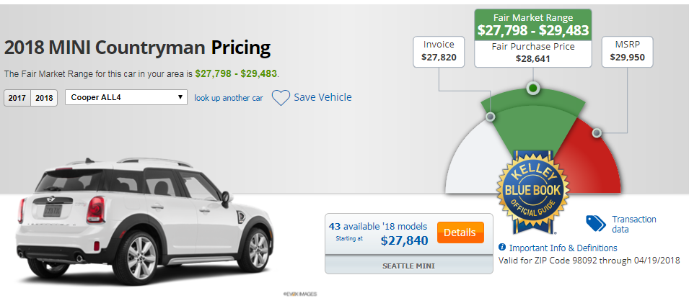

<https://www.kbb.com/mini/countryman/2018/cooper-all4/?vehicleid=432040&intent=buy-new&options=8165574|true> (Compare 2017 to 2018)

Shopping List Ideas:

|  |  |
| --- | --- |
| Used Car |  |
| New Car |  |
| Dream Car/Motocycle |  |

|  |  |  |  |  |  |  |  |  |  |
| --- | --- | --- | --- | --- | --- | --- | --- | --- | --- |
| Used Car | Make  Model  Year  Color | Special Features:  Gas mileage  Safety Rating  Warranty | Manufacturer Cost | Invoice Cost | Payment Terms  1, 2, 3, 4, 5, 6 or 7 years  (12, 24, 36, 48, 60, 72, 82) | Your Monthly Payment with 4%, and sales tax 10% <https://www.cars.com/car-loan-calculator/>  Down Payment? __________ | Other Costs:  Insurance, Maintenance, Gas, Plates, and Parking | Total Monthly Cost? | Picture |
|  |  |  |  |  |  |  |  |  |  |

Internet Resources:

|  |  |  |  |  |  |  |  |  |  |
| --- | --- | --- | --- | --- | --- | --- | --- | --- | --- |
| New Car | Make  Model  Year  Color | Special Features:  Gas mileage  Safety Rating  Warranty | Manufacturer Cost | Invoice Cost | Payment Terms  1, 2, 3, 4, 5, 6 or 7 years  (12, 24, 36, 48, 60, 72, 82) | Your Monthly Payment with 4%, and sales tax 10% <https://www.cars.com/car-loan-calculator/>  Down Payment? __________ | Other Costs:  Insurance, Maintenance, Gas, Plates, and Parking | Total Monthly Cost? | Picture |
|  |  |  |  |  |  |  |  |  |  |

Internet Resources:

|  |  |  |  |  |  |  |  |  |  |
| --- | --- | --- | --- | --- | --- | --- | --- | --- | --- |
| Dream Car/Motorcycle | Make  Model  Year  Color | Special Features:  Gas mileage  Safety Rating  Warranty | Manufacturer Cost | Invoice Cost | Payment Terms  1, 2, 3, 4, 5, 6 or 7 years  (12, 24, 36, 48, 60, 72, 82) | Your Monthly Payment with 4%, and sales tax 10% <https://www.cars.com/car-loan-calculator/>  Down Payment? __________ | Other Costs:  Insurance, Maintenance, Gas, Plates, and Parking | Total Monthly Cost? | Picture |
|  |  |  |  |  |  |  |  |  |  |

Internet Resources: