***Auburn Mountainview High School***

School Improvement Plan

Title I Schoolwide

Planning Year 2015­2016

Implementation September 2016­June 2019



School Improvement Plan Adopted by the Auburn School Board of Directors on *insert school board approval date here.*

September 2016­June 2019

Auburn School District Strategic Plan

***Aspiration:***

The Auburn School District aspires to be a world­class education system preparing al students to be global y competitive for career, for col ege, and for life in the twenty­first century.

***District Goal 1: Student Achievement***

Al staf in the Auburn School District provide support, leadership, and guidance to ensure each student meets or exceeds state and district standards, graduates on time, and is prepared for career and col ege.

***District Goal 2: Community Engagements***

Al staf in the Auburn School District are accountable for engaging its diverse community as partners to support and sustain a world­class education system.

***District Goal 3: Policies and Resource Management***

Auburn School District policies and resources are aligned to the strategic plan.

|  |  |  |  |
| --- | --- | --- | --- |
| **School:** | | | |
| **Auburn Mountainview High School** | | | |
| **Date of SIP Team District Goal Review:** | | | **August 16, 2016** |
| **SIP Team Members:** | | | |
| Terri Herren | Andrea McHenry | Monte Eckelman | Steve DuBay |
| Tom Ostrander | Chris Carr | Leah O’Brien | Tori Ammons |
| Heidi Bendt | Steve Calhoun | Kirsten Gravning | Theresa Haynes |
| Jessica Lee | Kevin Nishimoto | Telia McDonald | Sarah Samuelson |
| Tim Scott |  |  |  |

|  |  |  |  |  |
| --- | --- | --- | --- | --- |
| **School Improvement Team Signatures 2015­2016** | | | | |
| **Date Submitted:** | October 10,  2016 | **Date of School Board**  **Approval:** | |  |
| **Name** | **Title/Position** | | **Signature** | |
| Terri Herren | Principal | |  | |
|  | Parent | |  | |
|  | Student | |  | |
|  | Community Member | |  | |
| Andrea McHenry Monte Eckelman Steve DuBay | Assistant  Principals | |  | |
| Tom Ostrander  Chris Carr | Dean of Students  Athletic Director | |  | |
| Leah O’Brien Tori Ammons Heidi Bendt Steve Calhoun | Title I Coordinator  Department Chairs | |  | |

|  |  |  |
| --- | --- | --- |
| Kirsten Gravning Theresa Haynes Jessica Lee  Kay Lorrain Kevin Nishimoto Telia McDonald Sarah Samuelson Tim Scott |  |  |
| **Each team must include staff, students, families, parents, and community members.** | | |

***Signatures for Approval***

|  |  |  |  |
| --- | --- | --- | --- |
| **Department of Student Learning** | | | |
| Heidi Harris | Assistant Superintendent Student  Learning | |  |
| Julie DeBolt | Executive Director High  School/Post Secondary Programs | |  |
| Vicki Bates | Assistant Superintendent  Technology | |  |
| **Department of School Programs** | | | |
| Ryan Foster | Associate Superintendent Principal  Leadership and School Programs | |  |
| Rhonda Larson | Assistant Superintendent Family  Engagement and Student Services | |  |
| **Superintendent** | | | |
| Alan Spicciati | Superintendent |  | |
| **School Board** | | | |
| Anne Baunach | School Board |  | |
| Carol Seng | School Board |  | |
| Laurie Bishop | School Board |  | |

|  |  |  |
| --- | --- | --- |
| Ray Vefik | School Board |  |
| Ryan Van Quil | School Board |  |

Executive Summary – SWT 1

**COMPREHENSIVE NEEDS ASSESSMENT**

**Auburn School District Mission**

In a safe environment, al students wil achieve high standards of learning in order to become ethical y responsible decision makers and lifelong learners.

**Auburn School District Vision**

The vision of Auburn School District is to develop in students the skil s and attitudes that wil maximize their potential for lifelong learning and ethical y responsible decision making.

**Auburn Mountainview High School Mission**

In a mutual y respectful and safe community, each student wil

• Achieve high standards of learning

• Demonstrate responsible citizenship

• Value lifelong learning

**Auburn Mountainview High School Vision**

The vision of Auburn Mountainview High School is to develop, in students, the skil s and attitudes that wil maximize their potential for lifelong learning and ethical y responsible decision making.

**Background Information**

WAC 180­16­220

Requirements for School Improvement Plan

Each school shall be approved annually by the school board of directors under an approval process determined by the district board of directors and “At a minimum the annual approval shall require each school to have a school improvement plan that is data driven, promotes a positive impact on student learning, and includes a continuous improvement process that shall mean the ongoing process used by a school to monitor, adjust, and update its school improvement plan.” School Improvement plans must include a brief summary of use of data to establish improvement; acknowledging the use of data which may include DIBELS, MAP, WELPA, Credit Attainment, Enrollment in Honors/AP Courses, CEE Perceptual Data, SAT/ACT, Discipline, and MSP or HSPE.

**Stakeholder Input**

Our Leadership Team, under the guidance of Joe Rush, administrator intern, worked on the SIP/Title I Schoolwide Plan during our monthly Leadership Team meetings starting January, 2016. Between meetings department chairs got input on the goals from their departments. We had a half day release time Leadership Team Meeting in April to continue our work on the Action Steps for each goal. We formed a Literacy Goal Team that met in the morning before school once in May and again in June. The week of July 11­14, 2016 the Literacy Goal Team met to continue their work. The team met for three hours each day with representatives from Language Arts, Social Studies, World Languages, Performing Arts, and Visual Arts content areas.

Highly Qualified Staff – SWT 3

For the 2014/2015 school year, 97.7% of AMHS staf were highly qualified. In the 2015/2016 school year, 92% of AMHS staf were highly qualified. There are detailed plans in place for the remaining 8% of staf that are not highly qualified. Al of our classroom para­educators are highly qualified.

High Quality, Highly Qualified Teachers – SWT 5

For new teachers: Mentor teachers (in building) for al new staf , with additional mentoring time for teachers new to the profession. Our PD Specialists meet regularly with al new teachers in the building with additional meetings for teachers new to the profession. Also, Auburn School District conducts a new teacher orientation two weeks prior to the start of the school year. This orientation is for al teacher new to the district.

Al teachers: Al teachers col aborate in PLCs on Monday mornings to continual y improve instruction and learning outcomes for students. Staf are also provided support through in building and in district professional development to ef ectively implement our schoolwide strategies. Additional y, teachers are given opportunities to attend out of district conferences as they relate to our school improvement strategies. District of ice staf supports PLC by visiting building PLCs on scheduled visitation dates.

Professional Development Specialists: In 2015/2016, we added a 0.2 FTE PD specialist position. And in 2016/2017, we are adding an additional 0.2 FTE PD Specialist. Our PD Specialists work with individual or smal groups of teachers on improving instructional practice. The PD Specialists also assist with building PD planning and clock hour paperwork.

**Demographic**

o Auburn Mountainview had 1,490 students enrol ed in the 2012­2013 school year. Of those students, 61.9% are White, 13.1 % Hispanic/Latino, 9.0% Black/African American, 0.7% Native American/Alaskan Native, 1.5% Native Hawai an/Other Pacific Islander, 8.0% Asian, and 5.8% two or more races. In the 2013­2014 school year we had 1,532 students enrol ed. Of those students, 59.4% are White, 15.1% Hispanic/Latino, 8.8% Black/African American, 1.3% Native American/Alaska Native, 1.3% Asian/Pacific Islander, 9.0% Asian, and 5.5% two or more races. In the 2014­2015 school

year we had 1,531 students enrol ed. Of these students, 58.1% are White, 15.0% Hispanic/Latino, 8.4% Black/African American, 0.7% Native American/Alaska Native, 1.7% Native Hawai an/other Pacific Islander, 9.3% Asian, 6.7% two or more races. Our race/ethnicity demographics have remained similar over the past three years.

o In total, 40.2% of the 2012/2013 Auburn Mountainview student body qualified for free or reduced lunch. In 2013/2014 38.4 % of our students qualified for free or reduced lunch. In 2014/2015, 39.2% of our students qualified for free or reduced lunch. Our percent of students qualifying for free or

reduced lunch has remained near 40% over the past three school years.

o In 2012/2013, 6.6% of Auburn Mountainview students received special education services, 2.9% had Section 504 plans, and 5.5% were in the ELL

program. In 2013/2014, In 2013/2014, 6.8% received special education services, 2.9% had Section 504 plans, and 5.1% were in the ELL program. In

2014/2015, 4.9% received special education services, 2.7% had Section 504 plans, and 4.2% were in the ELL program. There has been a reduction in

the percent of students receiving special education services and the percent of ELL students. The percent of students with Section 504 plans has remained about the same.

**Discipline**

o In 2012/2013 there were 590 discipline actions for excessive tardies, 309 in 2013/2014, and 133 in 2014/2015. In 2012/2013 there were 468 discipline actions for truancy, 322 in 2013/2014, and 277 in 2014/2105. There has been a decrease in both excessive tardies and truancies from 2012/2013 to

2014/2015.

**Attendance**

o The average daily attendance in 2012 was 92%, in 2013 was 90.7%, in 2014 was 88.1%, in 2015 was 88.5%, and in 2016 was 87.5%. Our average daily attendance has been decreasing, from 92% in 2012 to 87.5% in 2016. Our Black/African American (from 86.6% to 86.3%), Hispanic/Latino

(from 85% to 84.8%), and Special Education (from 81.9% to 82.3%) student average attendance rate remained nearly the same from 2013 to 2016. Al other student populations had a decrease in their average attendance rate: Asian (from 94.9% to 91.8%), Native Hawai an/Pacific Islander (from 88.8% to 84.6%), White (from 91.3% to 84.9%), mutiracial (from 90% to 86.8%), and free/reduced lunch (from 89.4% to 85.5%).

**MAPS**

In the Fal 2015 MAP testing window we used the new Common Core MAP test in both reading and math. We used the MAP Common Core Math 6+ and the MAP Common Core Reading 6+.

For the 9th grade MAP Common Core Reading 6+ fal 2015/2016 test window, 10% of al students are high risk, and 12% are moderate risk, and 24% are on the bubble, for a total of 56%. Asian students are 22% high risk, 11% moderate risk, and 14% on the bubble for a total of 47%. African American students are

10% high risk, 18% moderate risk, 43% on the bubble for a total of 71%. Hispanic/Latino students are 11% high risk, 8% moderate risk, and 20% on the bubble for a total of 38%. Caucasian students are 7% high risk, 8% moderate risk, 20% on the bubble for a total of 35%. Our Asian students have a greater percent of students in the high risk and moderate risk categories combined than the other ethnic groups. Our African American students have a greater percent of students in the high risk, moderate risk, and on the bubble categories combined than the other ethnic groups.

For the 9th grade MAP Common Core Reading 6+ fal 2015/2016 test window, the strands tested have similar results. In the high risk category, we have 13%

of the students in the literature strand, 13% in the informational text strand, and 11% in the vocabulary acquisition and use strand. In the moderate risk category,

we have 15% in the literature strand, 15% in the informational text strand, and 15% in the vocabulary and acquisition strand. On the bubble, we have 19% in the literary strand, 23% in the informational text strand, and 20% in the vocabulary and acquisition strand.

Al students in Foundations Math, Algebra, or Geometry regardless of grade level, take the MAP Math 6+ in fal . For the 9th graders in the fal 2015/2016 test window, 13% of al students are high risk, 15% moderate risk, and 28% on the bubble for a total of 56%. Asian students are 8% high risk, 12% moderate risk, and 28% on the bubble for a total of 48%. African American students are 24% high risk, 26% moderate risk, and 32% on the bubble for a total of 82%. Hispanic/Latino students are 17% high risk, 16% moderate risk, and 33% on the bubble for a total of 66%. Caucasian students are 7% high risk, 15% moderate risk, and 26% on the bubble for a total of 48%. Our African American students and Hispanic/Latino students have the greatest percent of high risk and moderate risk combined (52% and 33%) and the greatest percent of high risk, moderate, and on the bubble combined (82% and 66%).

Looking at the strands for the 9th grade MAP Common Core Math 6+ fal test window, we have a total of 33% of our students in the high risk or moderate risk category for the operations and algebraic thinking strand, 46% in the real and complex number systems strand, 46% in the geometry strand, and 41% in the statistics and probability strand. Our students at the beginning of 9th grade are strongest in the operations and algebraic thinking strand. The percent of students on the bubble is very similar for al four strands, from 23%­25%.

**WELPA**

In 2012/2103, 80.0% of our ELL students made progress on the WELPA assessment. In 2013/2014, 79.6% made progress and in 2014/2015, 88.2% made progress. This is above the Auburn School District percent of 75.5% in 2012/2013, 75.2% in 2013/2014, and 75.7% in 2014/2015. Our school met state standard for “Making Progress” in 2013/2014 and 2014/2015.

In 2012/2013, 22.7% of our ELL students transitioned out of the program. In 2013/2014, 25.3% transitioned and in 2014/2105, 19.3% transitioned out of the program. This is above the Auburn School District percent of 13.2% in 2012/2013, 11.7% in 2013/2104, and 15.5% in 2014/2015. Our school met state standard for “Percent Transitioning” al three years.

**CEE Perceptual Survey**

In the 2014 CEE survey (our most recent survey) our parent perception (66%) of “Monitoring Teaching and Learning” is greater than both the student perception(45%) and staf perception(55%). This is similar to the results of the 2012 survey. Our administrators commented that there is a need to improve the monitoring of teaching and learning in the classrooms.

**SBA ELA**

Of the 71.2% of the 11th graders who took the 2015 SBA ELA test, 57.3% met standard. 74.8% of our Asian students, 69.5% of our Asian/Pacific Islander students, 45.2% of our African American students, 32.3% of our Hispanic/Latino students, 62.1% of our Caucasian students, 27.7% of our special education students, and 44.1% of our low income students met the Col ege and Career Ready ELA standard. Our Hispanic/Latino students and our special education students taking the on grade level SBA met standard at a much lower rate (32.3% and 27.7%) than the 11th graders as a whole. 28.8% of our 11th graders chose to not take the test.

Of the four claims, three of the claims had nearly the same percent of students below standard, Reading Claim 23.6%, Writing Claim 24.4%, and

Research/Inquiry Claim 22.8%. The Listening Claim had a much lower percent not meet standard, 11.4%.

**SBA Math**

Of the 70.2% of the 11th graders who took the 2015 SBA ELA test, 38.5% met standard. 62.9% of our Asian students, 23.8% of our African American students, 8.1% of our Hispanic/Latino students, 45.3% of our Caucasian students, 6.2% of our ELL students, and 27.5% of our low income students met the Col ege and Career Ready math standard. Our Hispanic/Latino students and our ELL students met standard at a much lower rate (8.1% and 6.2%) than the

11th graders as a whole. 29.8% of our 11th graders chose to not take the test including many students that have already met state graduation standard with either the EOC Algebra or EOC Geometry state assessments.

Of the three claims, two of the claims had nearly the same percent of students below standard, Problem Solving/Modeling/Data Analysis Claim 21.8%, and

Communicate Reasoning Claim 18.5%. The Concepts/Procedures Claim had much greater percent not meet standard, 44.8%.

**EOC Biology**

Staf analyzed Biology End­of­Course (EOC) data to identify chal enges in science. In 2014, 69.3 % of 10th graders did meet standard in science, compared to 73.4 % of 10th graders meeting standard in 2013. In 2015, 67.6% of our 10th graders met standard in science. The 2013 10th graders (class of 2015) are the first group of students required to pass the Biology EOC as part of their graduation requirements. The state suspended the science assessment graduation requirement for the class of 2016, with the requirement returning for the class of 2017. The percent of students meeting standard by the end of 10th grade is close to 70% each of the past three years.

**Graduation Rate**

Our adjusted on time graduation rate was 87.7% in 2009/2010, 91.9% in 2010/2011, 92.1 % IN 2011/2012, 84.2% in 2012/2013, and 90.9% in

2013/2014. This data was obtained from the OSPI Report Card for Auburn Mountainview High School. The 2012/2013 graduation rate was AMO

calculated and the remaining graduation rates were AYP calculated.

**AP/Honors**

From 2013/2014 to 2014/2015 the gap narrowed for Hispanic/Latino participation in Honors courses: in 2013/2014, 15.1 % of the population and 7.4% of the Honors students and in 2014/2015, 15.0 % of the population and 10.5% of the Honors students. The gap widened for Black/African American students: in

2013/2014, 8.8 % of the population and 4.1% of the Honors students and in 2014/2015, 8.4 % of the population and 3.0% of the Honors students.

From 2012/2013 to 2014/2015 the gap for AP classes remained about the same for Hispanic/Latino and Black.African American students. In 2012/2013, Hispanic/Latinos were 13.1 % of the population and 8.5% of the AP students and in 2014/2015, 15.0 % of the population and 10.6% of the AP students. In

2012/2013, Black/African Americans were 9.0 % of the population and 3.5% of the AP students and in 2014/2015, 8.4 % of the population and 2.9 % of the

AP students.

**Parent Involvement – SWT 6**

The OSPI Title I Parent Guide and the OSPI Title I Parent Right to Know pamphlets are available at Open House, Parent Conferences, on the school website, in the attendance of ice, and are sent home with our students. We also have a Title I link on the school website under the Families tab that includes the above OSPI Title I documents, district Title I documents, and AMHS Title I documents. The documents include the monthly “High School Parents Stil Make the Dif erence” with both English and Spanish versions available.

Title I Parent/Student/School Compacts are sent home with students in September. The Compact is also part of the registration packet for new students entering the building. In the 2014­2015 school year about half of the compacts were returned with the Federal Surveys. Another two hundred forms were returned through the end of January. To improve the return rate for the 2015/2016 school year the compacts and surveys were sent earlier with

new copies sent home two more times over the fol owing two weeks. About 80% of the compacts were returned. In 2016/2017, close to 90% of the compacts were returned.

Parents and students are given information about and encouraged to use the Skyward Family Access system to check grades and attendance. Students in CORE regularly review their grades in Skyward during their CORE time. With the increased access to technology, parents and students are encouraged often to access Skyward Student and Family Access to monitor attendance and student progress. In August, 2016 we added the A Plus app as another option of communication with students and families with information unique to Auburn Mountainview High School.

In November, 2014 we had a breakfast for our Russian and Ukranian families. This was coordinated by two of our teachers in the building who are bilingual. Terri Herren, building principal, and Denise Daniels, the district Family Engagement Coordinator also met with families during the breakfast. Families were given information on how to support their student in school, including accessing grades in Family Access and how to contact teachers. In the 2016/2017 school year we plan to expand this event to include other cultural groups in our school building.

Progress reports are sent home eight times during the school year, Open House is held in the fal , and Parent Conferences are in November. Also, seniors prepare and present their Culminating Projects to staf , family, and community members each spring. These opportunities are communicated to families by post cards mailed home, emails to parents, announcements on the school website, reminders to students to inform their parents, and automated phone cal s home. Parents are contacted by email and automated phone cal s concerning state testing dates, including individualized emails about a week prior to each test with the testing room for the particular student included. Parents also receive by mail student test results for state assessments and PSAT/SAT assessments. The PSAT/SAT results mailed home are for the in building administered testing. Counselors meet often with students to review graduation requirements and communicate regularly with parents of students not on track with graduation requirements.

Beginning with the 2016/2017 school year, staf wil make a minimum of four parents contacts per week and record al parent contacts in a Google form and share the form with the Title I Coordinator and their supervising administrator.

**Student Transitions – SWT 7**

8th grade to 9th grade: Counselors and other staf communicate with the middle school staf and also review MSP, SBA, MAP, EOC, grades, and teacher recommendations to assist in placing students to be successful in high school. In the 2014­2015 school year, the 9th grade Lion’s Den program was started. This program supports incoming 9th graders that need assistance in language arts and math to be successful in high school. A maximum of sixty students are placed in the program which includes smal class sizes and para­educator support for three class periods in the morning: math, language arts, science/orientation. During CORE al Lion’s Den students participate in a study skil s program. Also, two group of Lion’s Den students receive additional rea/writing assistance in the afternoon.

We have Lion’s Crew (Link Crew program) student mentors that meet with al ninth graders throughout the school year.

Between high school grade levels: Students that have not met state standards in math and language arts by the beginning of 12th grade are placed in courses to continue to work on meeting standards. Students that have not meet state standards in science by the beginning of 11th grade are placed in CORE to continue to work on meeting standards. Eleventh and twelfth grade Geometry students needing additional assistance are of ered an after school program that includes a snack. Select 9th through 11th grade ELL students participate in a study skil s class with an emphasis on reading and writing skil s. In 2015­2016 we added a 10th grade Lion’s Den program to continue to support about twenty of the students from the previous year’s

9th grade program and other identified students. During second semester of 2015­2016, we added an 11th grade class to assist students in meeting state standards in English Language Arts. In 2016­2017 this class wil be year long and included both 10th and 11th graders.

Our Summer School program includes Title I APEX recapture language arts and social studies for incoming 10th through 12th graders and non­grads. We of er Title I Math Support in Algebra, Geometry, Advanced Algebra and Title I Literacy Support in the areas of Language Arts and Social Studies. We of er Title I Science Support in Biology and Chemistry. Also, we have tuition based classes in Health, Walking, Culinary Arts, Horticulture Science, and APEX electives.

Beyond High School Transition: Twelfth graders complete a culminating project that incorporates post high school plans and meet with their advisor each month to check their portfolio/project progress. Our Career Center conducts many activities to assist students with plans after high school. These activities include col ege and career speakers, field trips, and classroom visits for students in al grade levels. Counselors meet often with students to review graduation requirements and communicate regularly with parents of students not on track with graduation requirements. Al students take either the PSAT or SAT in October, and eleventh graders take the SAT in March/April. Ninth graders participate in a Commit to Graduate Ceremony during orientation the first week of the school year.

**Assessment Decisions – SWT 8**

Results of the previous school year’s state assessments are reviewed annual y in August during the staf in service week activities. This data is analyzed more closely at the department level to inform improvement ef orts and classroom instruction. The data is also used to place students in our focused assistance programs. Other data reviewed and used for student placement include MAP, course grades, credits earned, and attendance.

**Effective, Timely Assistance – SWT 9**

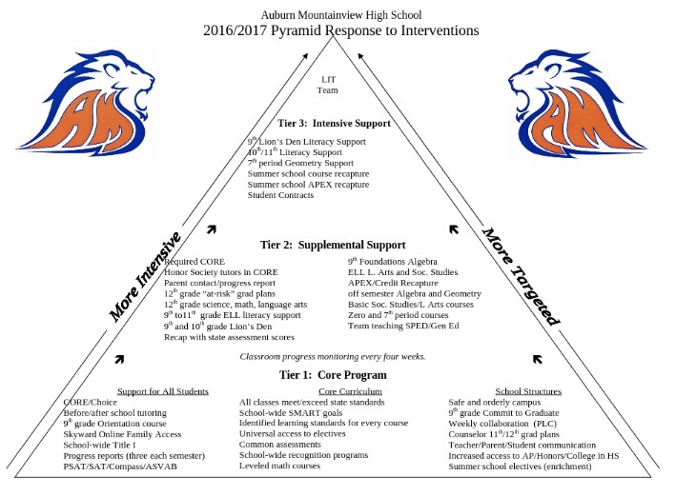

Prioritized Challenges

**Literacy Goal:**

Our Hispanic/Latino students and our special education students taking the on grade level 2015 SBA ELA met the Col ege and Career Ready Standard at a much lower rate (32.3% and 27.7%) than the 11th graders as a whole.

Our Black/African American students were the largest group scoring at level 1 (high risk) on the 2015 SBA ELA assessment.

28.8% (98 students) of our 11th graders chose to not take the 2015 SBA ELA test.

**Math Goal:**

Our Hispanic/Latino students and our ELL students met standard on the 2015 SBA Math at a much lower rate (8.1% and 6.2%) than the 11th graders as a whole.

In 2015, 29.8% (101 students) of our 11th graders chose to not take the SBA Math test, including many students that have already met the state graduation standard with either the EOC Algebra or EOC Geometry state assessments.

Of the 70.2% of the 11th graders who took the 2015 SBA Math test, 38.5% met standard.

**Graduation Goal:**

Many students are skipping CORE.

From second semester 2010/2011 school year when CORE was implemented, the number of students earning a D or F at semester has increased from 29.6%

to 36.6% in the first semester of 2014/2015 and then decreased slightly to 34.6% second semester 2015/2016.

From second semester 2010/2011 school year when CORE was implemented, the number of Fs per student for students that had a D or F at the end of each semester has decreased from an average of 2.2 per student to 1.0 per student first semester 2014/2015 and has increased to an average of 1.3 second semester 2016.

**SMART Goal 1:**

Math Goal: The percentage of 11th grade students meeting the Col ege and Career Ready standard on the SBA Math Assessment wil increase from 38.5%

in 2015 to 78.5% in 2019.

**SMART Goal 2:**

Literacy Goal: The percentage of 11th grade students meeting the Col ege and Career Ready standard on the SBA ELA Assessment wil increase from 57% in

2015 to 85% in 2019.

**SMART Goal 3:**

Graduation Goal: The percentage of students graduating on time wil increase from 90.9% in 2014 to 95% in 2018.

Needs Assessment Data Documents

**Race/Ethnicity**

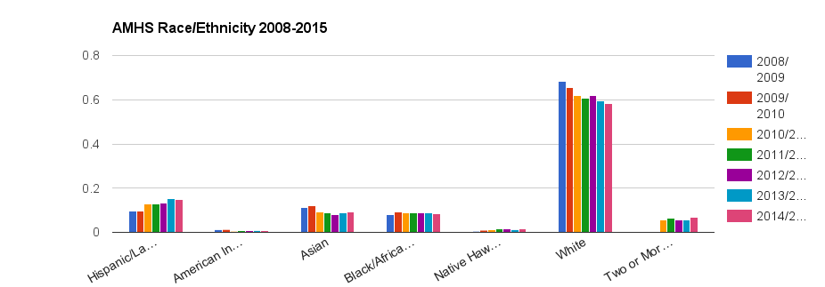

**MAP Reading**

**9th grade Fall2015 MAP Reading 6+ Common Core**

100% - 80-99 - 60-79



80% - 40-59 - 20-39



60% - 1-19

40%

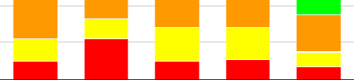

20%

0%

All Asian Black/

African

American

*Percentile*

Hispanic/ Latino

White

23 IPage upda!Pd 1Oill612016

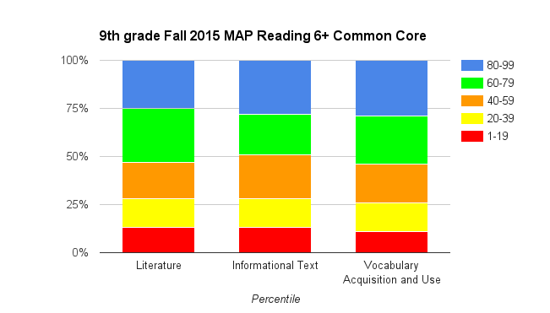

24 **|** Page updated 10/06/2016

**MAP Math**

100%

80%

60%

40%

20%

**9th grade Fall 2015 MAP Math 6+ Common Core**

- 80-99

- 60-79

- 40-59

- 20-39

- 1-19

0%

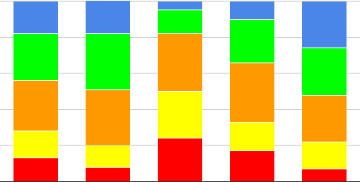

All

Foundations/ Alg/Geo

Asian Black/African Hispanic/ American Latino

*Percentile*

White

25 1 Page updated 10/06/2016

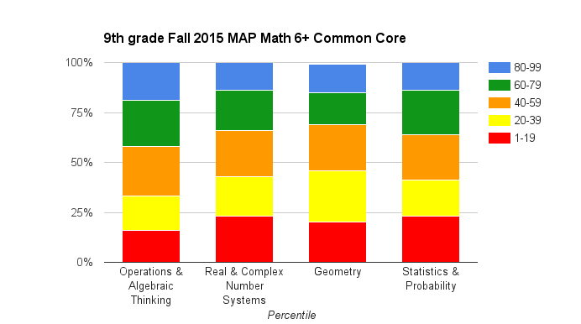

**WELPA**

**AMHS**

**ELL "AMAO"**

**AMAO 1:** Making Progress (based on WELPA)

**AMAO** 2: Attainment of English Proficiency (based on WELPA)

**AMAO** 3: Met Reading and Math Participation/Proficiency (based on State Assessments)

|  |  |  |  |  |  |  |  |
| --- | --- | --- | --- | --- | --- | --- | --- |
|  | **AMAOl** | (Target) | **AMA02** | (Target) | **AMA03**  Reading | Math | **Met AU**  **3AMAO** |
| 2011-12 | No /66.7%  (54 students) | (67.2%) | No/6.9%  (72 students) | (7.1%) | NR | NR | No |
| 2012-13 | Yes/80.0%  (55 students) | (67.5%) | Yes/22.7%  (75 students) | (7.4%) | Yes | No | No |
| 2013-14 | Yes/79.6% | (67.8%) | Yes/25.3% | (7.7%) | NR | NR | Yes |
|  | (54 students) |  | (79 students) |  |  |  |  |
| 2014-15 | Yes/88.2%  (51students) | (68.1%) | Yes/19.3%  (62 students) | (8.0%) | NR | NR | Yes |

NR= Number of students less than required

**CEE**

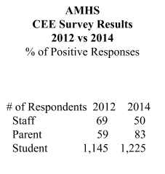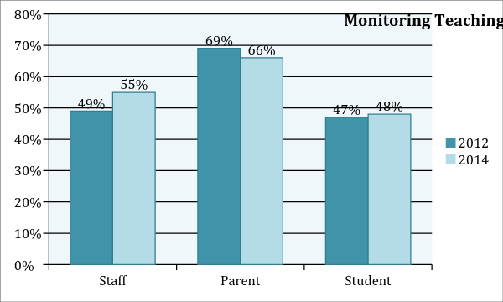

**Frequent Monitoring of Teaching and**

**Learning** (Student responses)



Monitolliirng of llreacll'l ng and Learning

--

1 2 a 4 5 e 7 111'111 9:1'111 10

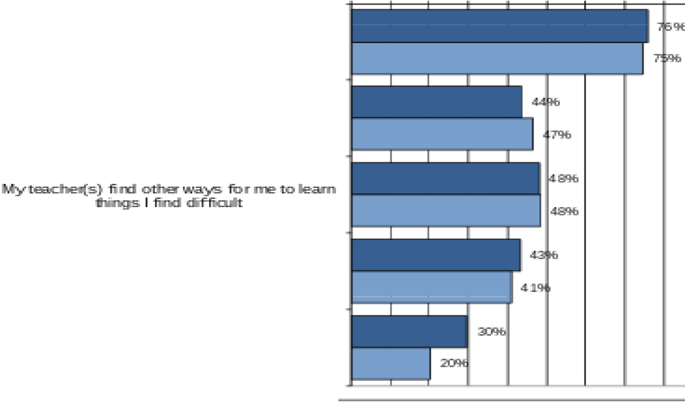

IcJe.ad:y II.Ddets1andl 1he befla.....UW Ides o'f this

:scfDol

IMiy :s)o **'d** In!' tiP pupose 'fOI" each

lesson or acfl...cty

Uy teachew(s) hetJo In!' leeun bycha.D;!ongiing In!'

oM iinEt"e:s:11111Q1 adl-..ities.in cla.'SS

loftensee tiP principaJ or .ad miiri>s'Oa.U.S

rnycla.>S_SIDom

. [)ec20 4 Dec:202



**Frequent Monitoring of Teaching and**

**Learning** (Parent respnnses)

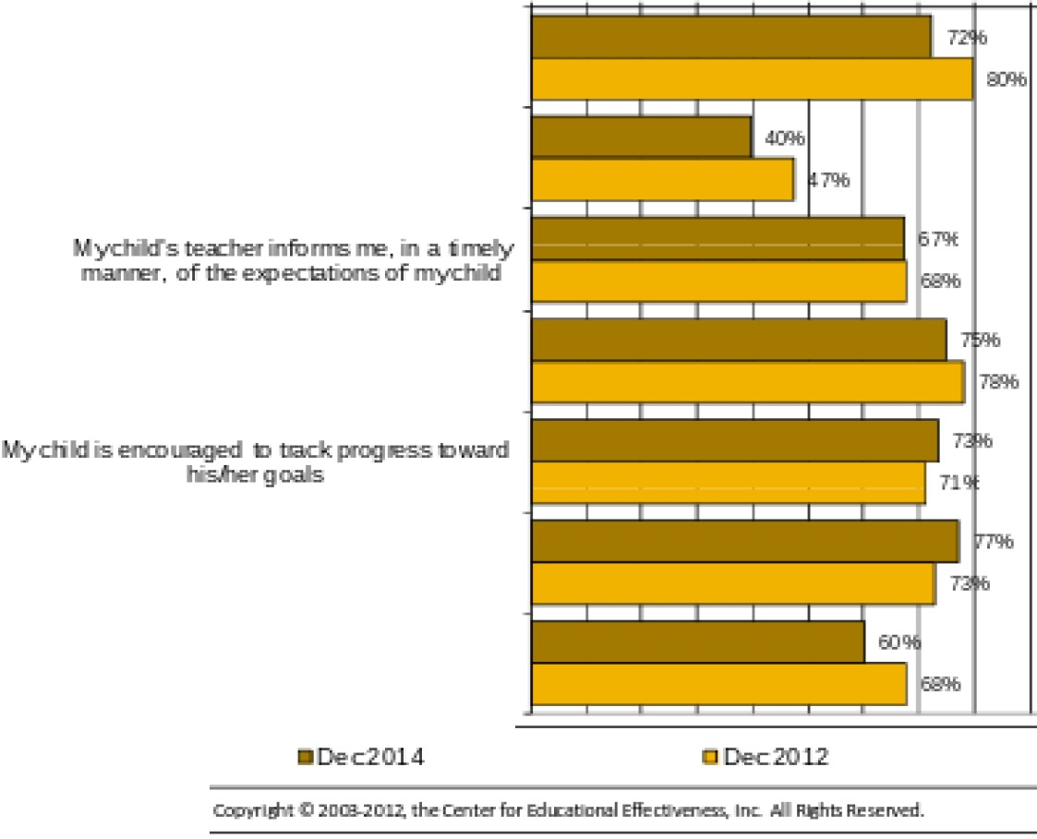

M>nitoliing of Teaching and Learning

fM !eM 21:M a :M 4CM 5CM 6CM 7CM 11CM 9CM 1001!11

Adcitiona.l help is a.r...SI<Die to mydildif hBfshe

needsit

TeachB's accomm da.temydilil"s"5pecia

needs byalliusfng iEtru:::tion

Iam gi-..en oppomrife-s to discuss R!{ciMs

PID9'es5 at seiDel

Mydild is gM!npro9e:s5 a'l!s ftom

h'S.iber tea.dB

IMiyctitd leams about the- a*u"es of o..­

corrnuityathis 01her school

30 I Page updated 10/06/2016

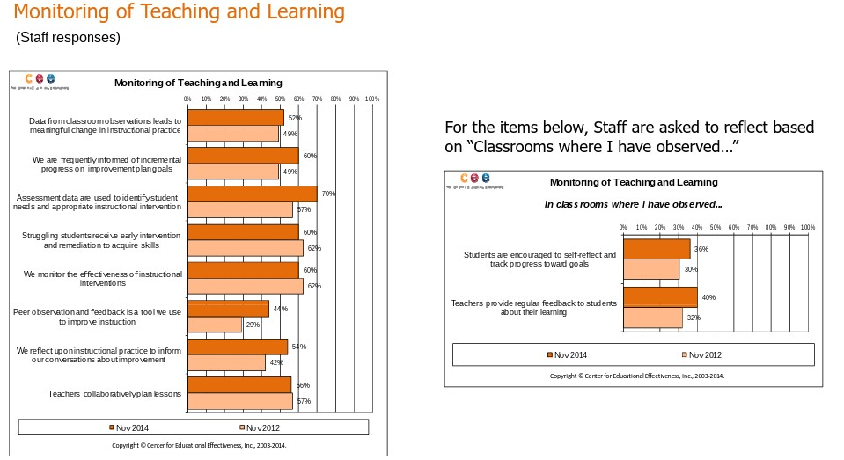

**Discipline**

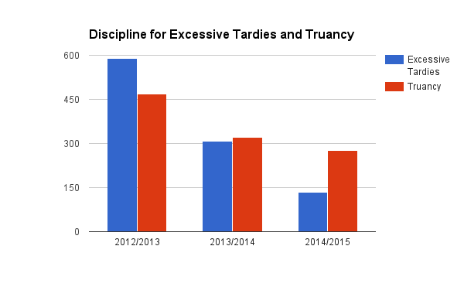

**Attendance**

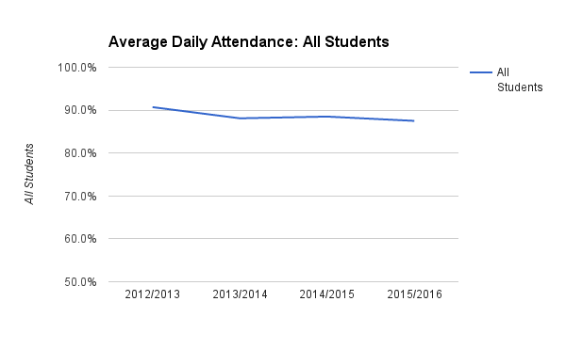

100.0%

900%

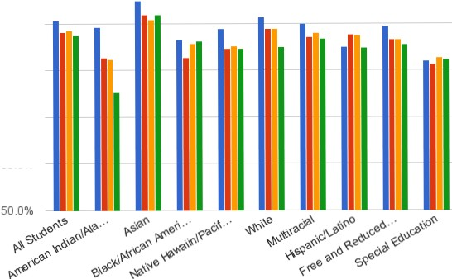

80.0%

70.0%

60.0%

34 1 Page updated 10/06/2016

**Average Daily Attendance**

- 201212013

- 201312014

- 2014/2015

- 2015/2016

**SBAELA**

100.00

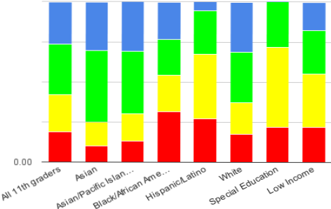

75.00

50.00

25.00

35 IPage updad 1010612016

**11th grade Spring 2015 SBA ELA**

- Level4

- Level3

- Level2

-Level1

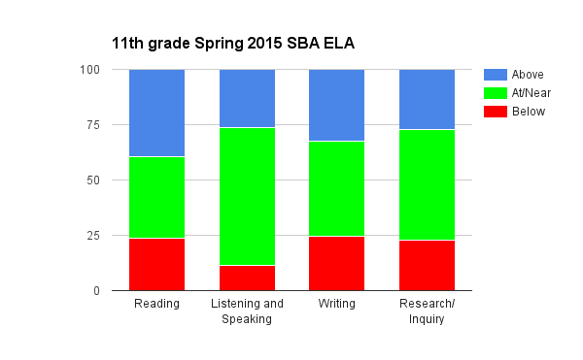

**SBA Math**

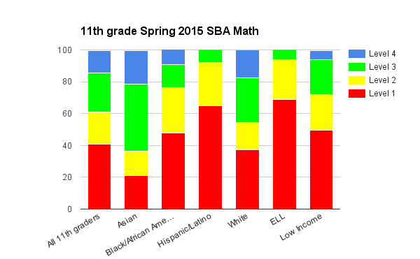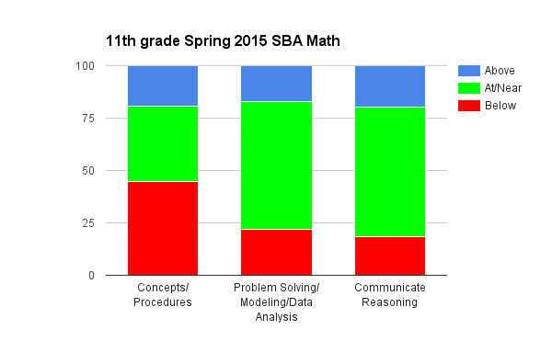

**EOC Biology**

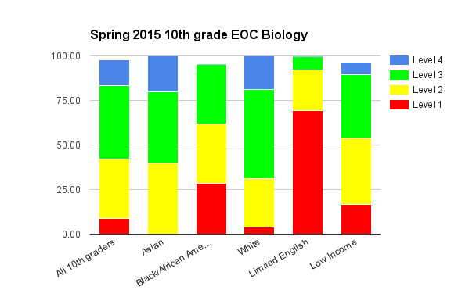

10th grade EOC Biology



6400%

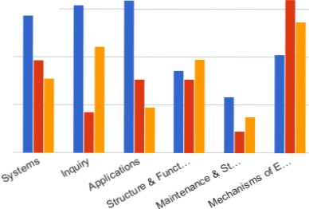

5600%

4800%

40.00%

40 1 Page updad 1010612016

- 2012/

2013

- 2013/

2014

- 20141

2015

**Credit Attainment** (12tb grade eod of semester ooe oat oo track to graduate)

40.0%

30.0%

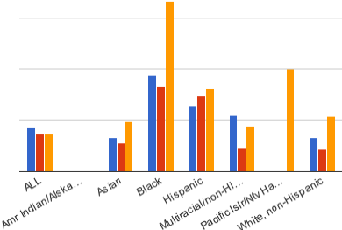

20.0%

10.0%

0.0%

**Credit Attainment: Percent of Students at Risk**

- 2012-2013

$1

- 2013-2014

$1

- 2014-2015

$1

41 IPage upda!Pd 10/0612016

**Honors/AP**

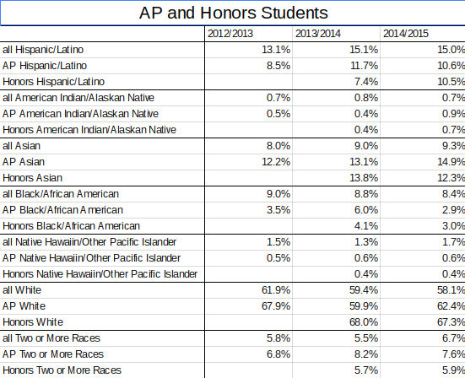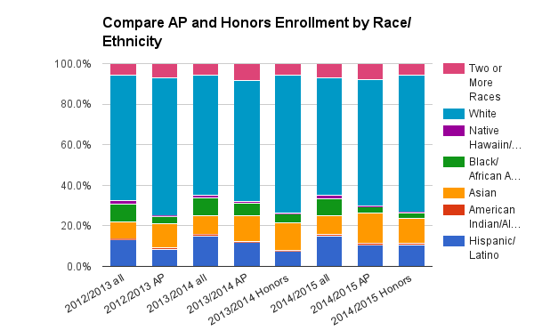

Title I Parent Survey

Title I Parent Survey September 2016 responses

**795 responses** 1: least important and 5: most important

summary

Extended Day and Sumner School opportunities

|  |  |  |
| --- | --- | --- |
| 1 | 151 | 19.3o/o |
| 2 | 104 | 13.3o/o |
| 3 | 245 | 31.4% |
| 4 | 141 | 18.1o/o |
| 5 | 140 | 17.9% |

200

150

100

50

0



1 2 3 4 5

Smallgroup instruction for reading,writing, math, and/or science

300



1 31 3.9o/o

2 46 5.9o/o

3 168 21.4o/o

225 4 228 29o/o



150 5 313 39.8o/o

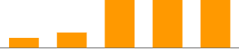

75

0

1 2 3 4 5

45 1 Page updated 10/06/2016

**Family math, science, reading and/or writing literacy events**

|  |  |  |
| --- | --- | --- |
| 1 | ***124*** | 15.9o/o |
| 2 | **132** | 16.9o/o |
| 3 | **261** | 33.5o/o |
| 4 | **161** | 20.6o/o |
| 5 | **102** | 13.1o/o |

250

200

150

100

50

0



1 2 3 4 5

Take home reading, writing, math, and/or science materials available to students

200

|  |  |  |
| --- | --- | --- |
| 1 | 48 | 6.1o/o |
| 2 | 76 | 9.7o/o |
| 3 | 183 | 23.4o/o |
| 4 | 230 | 29.4o/o |
| 5 | 244 | 31.2o/o |

150

100

50

I I

0

1 2 3 4 5

Training for parents to better understand how to help their students in reading, writing,math, and/or science

|  |  |  |
| --- | --- | --- |
| 1 | 91 | 11.6o/o |
| 2 | 119 | 15.2o/o |
| 3 | 216 | 27.6o/o |
| 4 | 186 | 23.8o/o |
| 5 | 170 | 21.7o/o |

200

150

100

50

0



1 2 3 4 5

Is there anything else you would like to see as a focus for our Title Iprogram that is not listed above?

Smaller class size, better website, better "Family Access." Less hypocritical dress code. Thank you.

Smaller class sizes

Peer group tutoring, after school.

Guidence counselors not arbitrarily based on last names, but best for student. Smaller class sizes. Tutoring before and after school.

Iknow a lot of parents that dont ha .e their teaching degrees. 0\er the years 1\e seen a strong push to im.ol .e parents in teaching their children. I feelparents should be in\OI .ed in pushing their children to get their assignments done and be prepared for class. But the school faculty should ha .e a stronger influence on the material taught. Ialso feel that school should ha .e less half days and off days.

No. Ithink the school is doing a great job.

More ways to catch up on credtis and ha .e students graduate w/ their regular class.

Enlisting competent writers to wrtie the article for our summaries. (my son's comments) Iam not a fan of these type of mandatted programs - Ifeel our educators are being pulled in too many directions at once.

1"\Jo. fnanK you.

You should go abo .e and beyond the call of duty for each child. summer schools

Opportunity for parents and teachers to communicate more frequently.. Example: mid year

conferences in addition to the fall.

Relates to #4 Class sets of books & students keep their own set at home so they donha .e to carry HEAVY backpacks. Or ha .e online textbooks available.

Ask the students - they know best what would help them. More parent, teacher contact

#1for allgrades #2 for all grades #4 to practice.No homework for all grades. Tutoring before/after school

Focus on the learning styles of students.

Ithink practical math would be a nice addition. (budgets, balancing a check book. calculating net

IB take home pay)

Iwould like to see the schooloffer tablet de\.ices, e-books, and wireless networks instead of hard copy books & paper. Classes should be offered both onilne & tradti ional classroom or mix. We need to bring school into the 21st century. Would like to see logic & critical thinking as a mandatory course. Offer martial arts to kids. Offer smoothies during lunch so that kids will eat

fruit and .eggies.

computer Science as a CTI credit

provide it in spanish for the all the parents that don't know a lot of English More teacher/student time for questions if needed on school work. Personal technology devices instead of books.

Classrooms for students that need the extra help that are EIP but do not ha .e disrupti .e problems. Its .ery hard to learn when there are a lot of ADHD + ADD and high end special ED in the same class.

-social studies

Math workshops, extended help for students struggling with math comprehension

School text books for kids to study (take home and bring back)

4 day week instead of 5

Tutoring

Less relience on technology -teach basics, so that students know how to mentally do things like math and English.

After school student help for homework

No papers like this

No more papers like this.

Social behavior "team work exercises"

Instead of extended day how about the day start late.

Opportunited for gifted students to help struggling students in exchange for some sort of extra credit, or other reward.

Iam ry pleased with mountain \.lew. The staff are kind, respectful and in e ry acts as though they really care about each indi\.idual student. This is the best school I haer seen or been

in AJId with.

Irefuse to sign this -These are my responsibilities as a parent - not for you to tell me.

Less reliance on technology -teach basics so that students know how to actually do things like math and Engilsh.

Our teaches and adimistrators are awesome so if some students are not able to keep up Idon't beliethey should be penalized.

for those that need it! Robotics

You should haa little I AJcabulary program that emphasizes the latin or greek root words of

our American AJCabulary

Ifind it interesting that there is an expectation that students will haa smartphone to internet with teachers/classes (ex: Remind). This is part of the digtial di\.ide.

ARTS ARTS ARTS ARTS ESP BAND MORE ART FUNDING

**CORE** (CORE started 2nd semester 2011/2012)

**Percent of students with aD and/or F**

40.0%

30.0%



20.0%

0

*\*'*

10.0%

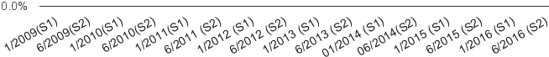

**Av erage number offailing grades for students with a D and/or F**

1":''

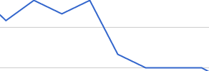

2.4

*<I>* 1.8

._ 1.2

*<I>*

Q.

u_

*<I>*

1._6' 0.6

"'

0.0



**Algebra and Geometry Courses**

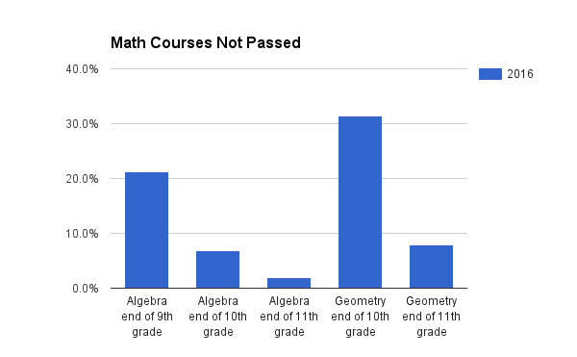

**Graduation Rate**

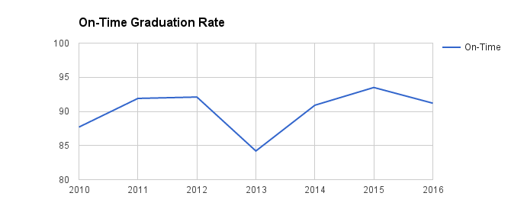

|  |  |
| --- | --- |
| **SMART Goal 1** | |
| **Subject Area: Mathematics** | |
| **School Name:** | Auburn Mountainview High School |
| **Target Population­ *based on demographic, discipline and attendance data analysis:*** | Students that have not met standard (course grade of 60% or above) in their Algebra course by the end of 10th grade. Students that have not met standard (course grade of 67% or above) in their Geometry course by the end of  11th grade. |
| **Our Reality­*based on assessment data analysis:*** | In 2016, 21.3% (78 students) of our 9th graders, 6.8% (26 students) of our 10th graders and 2.0% (7 students) of our 11th graders had not passed Algebra by the end of semester 2.  In 2016, 31.4% (120 students) of our 10th graders and 7.9% (28 students) of our 11th graders had not passed  Geometry by the end of semester 2.  In 2015, 29.8% (101 students) of our 11th graders chose to not take the SBA Math test, including many students that have already met the state graduation standard with either the EOC Algebra or EOC Geometry state assessments.  Of the 70.2% of the 11th graders who took the 2015 SBA Math test, 38.5% met the Col ege and Career Ready standard.  Our Hispanic/Latino students and our ELL students met the Col ege and Career Ready standard on the 2015 SBA Math at a much lower rate (8.1% and 6.2%) than the 11th graders as a whole. |
| **Our SMART Goal­*based on target population and your reality:*** | The percentage of 11th grade students meeting the Col ege and Career Ready standard on the SBA Math  Assessment wil increase from 38.5% in 2015 to 78.5% in 2019. |
| **Action Plan** | |

**Action Step**

**SWT 2 All students will be supported in passing Algebra by the end of 10th grade.**

|  |  |  |  |  |
| --- | --- | --- | --- | --- |
| **Evidence of Implementation** | **Evidence of Impact** | **Timeline** | **Resources** | **Responsibility** |
| Analysis of Fall MAP data to plan instruction, including scaffolding, to better meet the needs of students.  Engage students in understanding their Fall  MAP performance in areas for improvement.  Analysis of district formative and  summative assessments to plan instruction. Spiral assessments. | All students meeting standard (minimum of 75%) on the district formative and summative Algebra assessments.  Using the concept test summary sheet, students are able to articulate their continuum of learning to successfully meet standard on each Algebra concept in the district curriculum.  There will be a decrease in the percent of students that haven’t completed  Algebra by the end of 10th grade. | 2016/2017 through  2018/2019 school year | PLC time to analyze assessment data.  Kuta PreAlgebra software to support basic skills.  Staff PD on use of MAP  data | Math department chairs  Algebra teachers |
| **Action Step** | **SWT 2 All students will be supported in passing Geometry by the end of 11th grade.** | | | |
| **Evidence of Implementation** | **Evidence of Impact** | **Timeline** | **Resources** | **Responsibility** |
| Analysis of Fall MAP data to plan instruction, including scaffolding, to better meet the needs of students.  Engage students in understanding their Fall  MAP performance in areas for improvement.  Analysis of district formative and  summative assessments to plan instruction. Spiral assessments. | All students meeting standard (minimum of 75%) on the district formative and summative Geometry assessments.  Using the concept test summary sheet, students are able to articulate their continuum of learning to successfully meet standard on each Geometry concept in the district curriculum.  There will be a decrease in the percent of students that haven’t completed Geometry by the end of 11th grade. | 2017/2018 through  2018/2019 school year | PLC time to analyze assessment data.  KUTA PreAlgebra software for to support basic skills.  Staff PD on use of MAP  data  Need additional para, teacher or other staff time to contact parents of | Math department chairs  Geometry teachers |

|  |  |  |  |  |
| --- | --- | --- | --- | --- |
|  |  |  | students that are absent or tardy to the after school Geometry program. |  |
| Alignment to District Improvement Plan Objec ves:  GOAL 1: Student Achievement  All staff in the Auburn School District provide support, leadership, and guidance to ensure each student meets or exceeds state and district standards, graduates on time, and is prepared for career and college.  Objective 3: The Auburn School District will utilize the Center for Educational Leadership’s Five  Dimensions of Teaching (CEL 5D) as the Instructional Framework.  Strategy 2  Teachers and administrators monitor student learning and adjust instruction to ensure achievement of standard. | | | | |

**SMART Goal 2**

|  |  |
| --- | --- |
| **Subject Area: Literacy** | |
| **School Name:** | Auburn Mountainview High School. |
| **Target Population­ *based on demographic, discipline and***  ***attendance data analysis:*** | Students that have not met College and Career Ready ELA standard by the end of 11th grade. |
| **Our Reality­*based on assessment data analysis:*** | 28.8% (98 students) of our 11th graders chose to not take the SBA ELA test.  Our Hispanic/Latino students and our special education students taking the on grade level 2015 SBA ELA met the Col ege and Career Ready standard at a much lower rate (32.3% and 27.7%) than the 11th graders as a whole (57.3%).  Our Black/African American students were the largest group scoring at level 1 (high risk) on the 2015 SBA ELA  assessment |
| **Our SMART Goal­*based on target population and your reality:*** | The percentage of 11th grade students meeting standard on the SBA ELA Assessment wil increase from 57% in  2015 to 85% in 2019. |
| **Action Plan** | |

|  |  |  |  |  |
| --- | --- | --- | --- | --- |
| **Action Step** | SWT 2 Al students wil be supported in their understanding and application of five literacy skil s in al content areas: central idea and key details, inference, compare/contrast, analyze, and evaluate. | | | |
| **Evidence of Implementation** | **Evidence of Impact** | **Timeline** | **Resources** | **Responsibility** |
| All content area teachers will intentionally integrate instruction and student practice with central idea and key details, inference, and compare/contrast. (Year 1, 2016/2017) | There will be an increase in the percent of students proficient as measured by our three schoolwide assessements (September, December, March). | 2016/2017: first three literacy skills | Lesson plans examples developed by the Literacy Team.  AMHS PD Specialists. | teachers |

|  |  |  |  |  |
| --- | --- | --- | --- | --- |
| All content area teachers will intentionally integrate instruction and student practice with central idea and key details, inference, compare/contrast, analyze, and evaluate. (Year 2­3, 2017/2018 and 2018/2019) | There will be an increase in the percent of 11th grade students meeting College and Career Ready standards as measured by the SBA ELA. | 2017/2018 and  2018/2019: all five literacy skills | Three schoolwide PLC  days.  Waiver day and building PD hours for professional development. |  |
| Alignment to District Improvement Plan Objec ves:  GOAL 1: Student Achievement  All staff in the Auburn School District provide support, leadership, and guidance to ensure each student meets or exceeds state and district standards, graduates on time, and is prepared for career and college.  Objective 3: The Auburn School District will utilize the Center for Educational Leadership’s Five  Dimensions of Teaching (CEL 5D) as the Instructional Framework.  Strategy 2  Teachers and administrators monitor student learning and adjust instruction to ensure achievement of standard. | | | | |

|  |  |
| --- | --- |
| **SMART Goal 3** | |
| **Subject Area:** | |
| **School Name:** | Auburn Mountainview High School |
| **Target Population­ *based on demographic, discipline and***  ***attendance data analysis:*** | Students not graduating on time. |
| **Our Reality­*based on assessment data analysis:*** | Many students are skipping CORE.  From second semester 2010/2011 school year when CORE was implemented, the number of students earning a D or F at semester has increased from 29.6% to 36.6% in the first semester of 2014/2015 and then decreased slightly to 34.6% second semester 2015/2016.  From second semester 2010/2011 school year when CORE was implemented, the average number of Fs per student for students that had a D or F at the end of each semester has decreased from an average of 2.2 per student to 1.0 per student first semester 2014/2015 and has increased to an average of 1.3 per student second semester  2016. |
| **Our SMART Goal­*based on target population and your reality:*** | The percentage of students graduating on time wil increase from 90.9% in 2014 to 95% in 2018. |
| **Action Plan** | |

|  |  |  |  |  |
| --- | --- | --- | --- | --- |
| **Action Step** | SWT 2 Students wil be supported in improving their attendance during CORE. | | | |
| **Evidence of Implementation** | **Evidence of Impact** | **Timeline** | **Resources** | **Responsibility** |
| CORE placement staff will place all students in a CORE class or a CHOICE class. | There will be a decrease in the average percent of students truant for CORE each day. Average daily attendance will | 2016/2017 through  2018/2019 school year. | additional CORE  placement staff to place | Teachers  CORE placement staff |

|  |  |  |  |  |  |  |
| --- | --- | --- | --- | --- | --- | --- |
| All teachers will promptly take attendance for their CORE and CHOICE sections prior to releasing CHOICE students from their classroom. | | | be calculated at the end of each semester. |  | students in both CORE  and CHOICE classes | Dean of Students |
| **Action Step** | | | **SWT 2 All students will be supported during CORE in improving their course grades.** | | | |
| **Evidence of Implementation** | | | **Evidence of Impact** | **Timeline** | **Resources** | **Responsibility** |
| Staf are actively engaged in assisting students with improving their grades utilizing the CORE Plan Sheet. | | | Students are actively engaged in improving assignments and assessment scores during CORE utilizing the CORE Plan Sheet.  Decrease in the percent of students with D and F grades at the end of each semester. | 2016/2017 through  2018/2019 school year. | CORE Plan Sheet  Career Center  Counselor | Teachers  Administrators |
| Alignment to District Improvement Plan Objec ves:  GOAL 1: Student Achievement  All staff in the Auburn School District provide support, leadership, and guidance to ensure each student meets or exceeds state and district standards, graduates on time, and is prepared for career and college.  Objective 5  The Auburn School District will increase and continue to exceed the State of Washington’s on­time and extended high school graduation rates. | | | | | | |
|  | Strategy 2 |  | | | | |

The Auburn School Di'itrict aclmini'itrators, principal<;, and teachers support student transitions from kindergarten through grade 12 by monitoring and intervening with students exhibiting

at-risk indicators including attendance, academic, health, sociaeconomic, and di'icipline.

Planning and Implementation Calendar (SWT‐4)

|  |  |  |  |  |  |  |
| --- | --- | --- | --- | --- | --- | --- |
| Month | Building Hours | Staff  Meetings | LTM Meetings | District/Waiver  Days | Title Other  Hours | Other Building  Activities |
| July |  |  |  |  | July 11­14  Literacy Team |  |
| August | August 29 7.5 hrs Retreat  SIP Goals and Literacy Skills  August 30 7 hrs. Paper  Tigers  August 31 4.5 hrs. Digital  Literacy/Staff Meeting |  |  | August 31 2.5 hrs. District Kick­Off | August 3  Literacy Team | August 25  Lion Pride Day |
| September | September 22 3.25 hrs. Open House | September 8  Superintenden t Spicciati  September 28  New Teacher  Meeting | September 20  1.25 hrs. | September 1 ARHS  7 hrs.  Department Breakout  Meetings | September 13  SIP Needs Assessment (district) | September 19­20  Baseline student literacy assessment  September 26  Title para PLC |
| October |  | October 12  New Teacher  Meeting  October 26  New Teacher  Meeting | October 18  1.25 hrs. | October 14 Literacy Skills and Technology in the Classroom |  | October 10  Schoolwide PLC Literacy Skills PD |
| November | November 10 3 hrs. Parent/Teacher Conferences | November 9  New Teacher  Meeting | November 15  1.25 hrs. |  |  |  |

|  |  |  |  |  |  |  |
| --- | --- | --- | --- | --- | --- | --- |
|  |  | November 22  New Teacher  Meeting |  |  |  |  |
| December |  | December 7  New Teacher  Meeting | December 20  1.25 hrs. |  |  | December 13  Student literacy assessment |
| January |  | January 7  New Teacher  Meeting  January 18  New Teacher  Meeting | January 17  1.25 hrs. |  |  |  |
| February |  | February 1  New Teacher  Meeting | February 14  1.25 hrs. |  |  | February 13  Schoolwide PLC Literacy Skills PD |
| March |  | March 1  New Teacher  Meeting | March 21  1.25 hrs. | March 6 Waiver Day |  | March 21  Student literacy assessment  March 27  Schoolwide PLC Literacy results review |
| April | Senior Presentations 4 hours  (exact day TBD) | April 5  New Teacher  Meeting | April 18  1.25 hrs. |  |  |  |
| May |  | May 3 New Teacher Meeting | May 16  1.25 hrs. | May 8 Waiver Day |  | May 22  Schoolwide PLC Review 16/17 rosters |
| June | June 14 3 hrs. Greaduation | June 6 | June 20  1.25 hrs. |  |  |  |

|  |  |  |  |  |  |  |
| --- | --- | --- | --- | --- | --- | --- |
|  |  | New Teacher  Meeting |  |  |  |  |

Budget ­ SWT# 10

|  |  |  |  |
| --- | --- | --- | --- |
| Funding Matrix | 2014/2015 | 2015/2016 | 2016/2017 |
| BEA | $ 5,931,722 |  |  |
| Local Levy | $ 1,673,050 |  |  |
| Title I | $ 159,657 | $ 345,644 | $380,000 (estimate) |
| Total | $ 7,764,429 |  |  |